START OF THE LEGAL FINANCING REQUEST QUESTIONNAIRE
Before we begin, we need to clarify an important point to avoid any duplication or confusion in funding requests.
Have you, or someone else on your behalf, already submitted a legal financing request to "Compensate Me"?
- Yes
  - Please provide the reference number of this request if available and contact our customer service for any necessary modifications or updates.
- No
  - Continue with the questionnaire to determine your role in the financing request process.
Main Questionnaire:
Are you seeking financial support to cover legal expenses?
- Yes
  - You are potentially a Financed Party.
    - 1.1. Are you acting alone, or are you representing other parties in this request?
      - Alone: You are a Financed Party.
        - Reminder: Please fill in your personal information only.
      - I represent other parties:
        - 1.1.1 Are any of the parties you represent your minor children?
          - Yes: Please indicate this when providing their information.
          - No: Continue to the next question.
        - 1.1.2 Have you been appointed as the principal representative by the other financed parties?
          - Yes: You are the Principal Representative of the Financed Parties.
            - Reminder: Fill in your personal information and that of the Co-Financed Parties, including any minor children you represent.
          - No: You are a Co-Financed Party.
            - Reminder: If the Principal Representative of the Financed Parties has not yet submitted a request, you have the option to submit the request on your own behalf, thereby becoming a Financed Party.
              - If choosing to submit on your own behalf, please fill in your personal information only.
- No
  - Proceed to question 2.
Are you acting as a mandate to secure compensation on behalf of other parties?
- Yes: You are a Compensation Mandate.
  - Reminder: Fill in your personal information and that of the parties on whose behalf you are requesting compensation.
- No: If you do not fit into any of the above categories, please contact our customer service for personalized assistance.
Role Reminders:
- Financed Party: An individual, company, or entity receiving financial support for legal expenses under a financing agreement.
- Principal Representative of the Financed Parties: A natural or legal person appointed by a group of Financed Parties to act on their behalf and represent their common interests under a legal financing agreement.
- Co-Financed Party: An individual, company, or entity that jointly participates in a Financing Agreement and has agreed to assign the role of Principal Representative to act on their behalf in dealings with the Financing Provider.
- Compensation Mandate: Takes necessary steps, in consultation with the Financing Provider, to ensure that the Financed Party's rights to compensation are effectively exercised and that any compensation received is correctly attributed to the Financed Party.

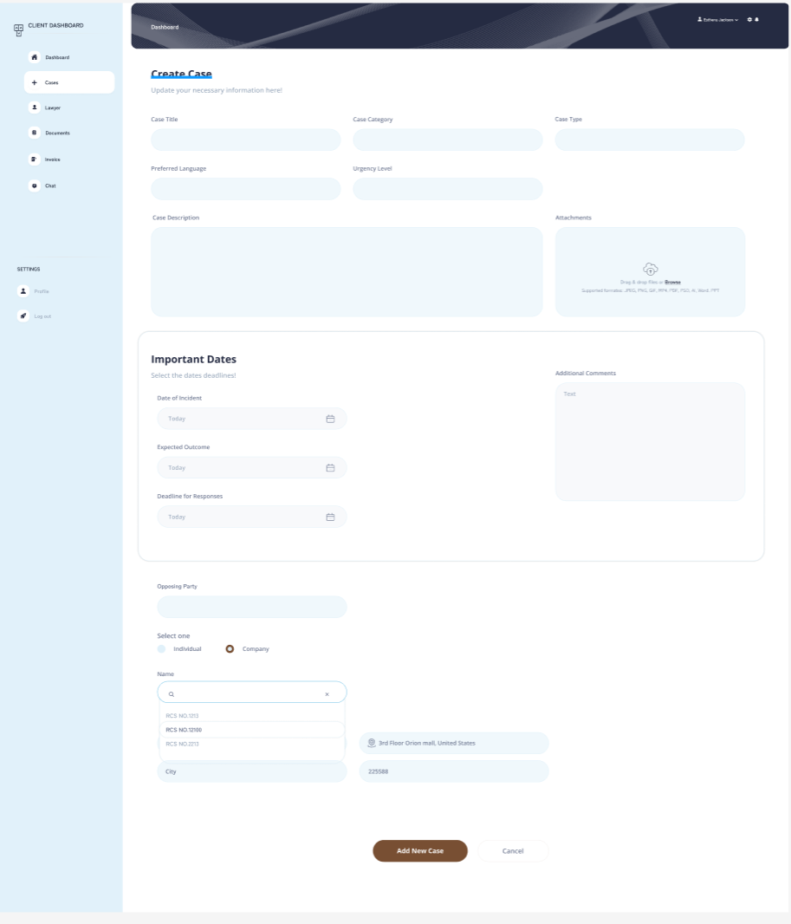

FINANCING OFFER PROCESS AND LAWYER SELECTION WORFLOW DIAGRAM

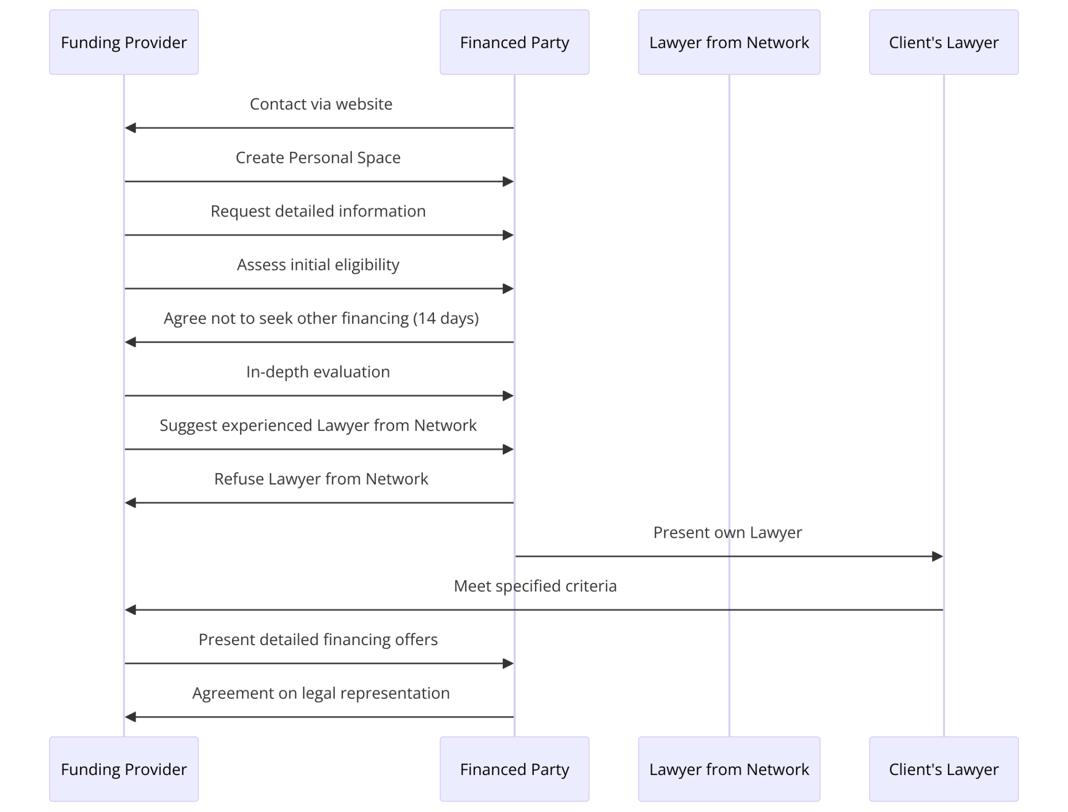

FINANCING OFFER PROCESS AND LAWYER SELECTION STEPS

Contact via Website: The potential Financed Party initiates the process by contacting the Funding Provider through their website.

Create Personal Space: A secure Personal Space is created on the platform for the Financed Party to provide information.

Request Detailed Information: The Funding Provider requests detailed information regarding the dispute for an initial eligibility assessment.

Assess Initial Eligibility: The Funding Provider assesses the information to determine initial eligibility for financing.

Agree Not to Seek Other Financing (30 days): The Financed Party agrees not to seek other financing options for a period of 30 days, allowing the Funding Provider to conduct its analysis.

In-Depth Evaluation: The Funding Provider performs a more thorough evaluation of the case to decide if it meets the criteria for funding.

Suggest an Experienced Lawyer from Network: The Funding Provider suggests an experienced lawyer from its network to represent the Financed Party.

Refuse Lawyer from Network: The Financed Party can refuse the suggested lawyer from the network.

Present Own Lawyer: If the Financed Party refuses the lawyer from the network, they may present their own lawyer, provided that the lawyer meets specified criteria.

Meet Specified Criteria: The presented lawyer must meet the criteria set forth by the Funding Provider.
- Preparation Detailed Financing Offers:
- After a comprehensive in-depth evaluation of the case, the Funding Provider prepares one or more financing offers. These offers are meticulously crafted to cover the anticipated costs of the Indemnity Proceedings.
- Each financing offer includes detailed breakdowns of the amounts the Funding Provider is willing to fund and the Commission rate.

- Presentation Offers:
- These financing offers are then presented to the Financed Party. The presentation is designed to be transparent, with each offer clearly outlining the financial commitment from the Funding Provider and the obligations of the Financed Party.
- The presentation via a detailed document. The financing offer selected by the Financed Party is shared electronically. The goal is to ensure that the Financed Party fully understands each element of the offers.

- Clarification and Consultation:
- The Financed Party is encouraged to ask questions, seek clarifications, and consult with advisors or legal counsel to understand the implications of each offer fully. This step is crucial for making an informed decision.
- The Funding Provider is available to provide additional information, answer questions, and make any necessary revisions to the offers based on feedback from the Financed Party.

- Agreement on Legal Representation: Following the presentation of financing offers, an agreement is reached regarding the legal representation of the Financed Party.

WORFLOW INITIAL REPORT ANALYSIS TO DEPTH ANALYSIS REPORT TO FINANCING PROPOSALS

Based on the provided statistics, either through API integration or by utilizing OCR (Optical Character Recognition) technology, we can automate the generation of a report for the client. I have a meeting with LexisNexis on March 12th and one with Thomson Reuters on March 27th. From there, it will be easier to conceptualize how the data will be presented and transmitted, likely more efficiently than in the bellow example. We will revisit the key values, including maximums and minimums, weightings, etc. This will be paralleled with graphical illustrations. Until I have had these meetings, it seems premature to work on this page.

From the "INITIAL REPORT ANALYSIS" page, we will identify a set of questions and requests for additional documents from the client to transition to the "IN DEPTH ANALYSIS REPORT" page. This process allows us to gather more detailed information and data necessary for conducting a thorough and comprehensive analysis. By obtaining these extra documents and answers, we can refine our understanding of the client's situation, enabling a more precise and tailored approach in the subsequent, in-depth analysis.

From the "IN-DEPTH ANALYSIS REPORT," we will automate the creation of “FINANCING PROPOSALS” internally to determine the amount of fees we are willing to commit. Based on this, we will then proceed to search for a suitable attorney. However, it's important to note that we will only transmit the financial proposals to the client once we have identified and proposed a lawyer to them. This approach ensures that our financial commitments and proposals are aligned with the legal representation options available and suitable for the client's need.

EXAMPLE OF INITIAL ELIGIBILITY REPORT RECEIVED BY INDEMNISEZ MOI

Example: the values are not correct and the form of the report will depend on the service provider chosen

265 decisions from december 19, 2000 to may 06, 2021
Trial courts
Average 1st instance > Appeal 2 years 6 months
Longest cases
- 6 ans 4 mois
- 5 ans 2 mois
Shortest cases
- 11 mois
- 13 mois

First Instance

Conviction / Annulment
15 decisions
45.45%

Dismissal / Rejection
15 decisions
45.45%
15 convictions: 45.45%
15 standing: 45.45%
3 other: 9.09%

Second Instance

Confirmation on appeal
103 decisions
49.28%

Reverseal on appel
45 décisions
21.53%
30 infirmations: 14.35%
15 partial infirmations: 7.18%
61 other: 29.19%
Appeals to the Supreme Court 8.68% of cases
Average appeal > Cass. 1 year 10 months
Longest cases
First instance
Conviction / Annulment
15 decisions
45.45%
Dismissal / Rejection
15 decisions
45.45%
15 convictions : 45.45%
15 standing: 45.45%
3 other: 9.09%
Second instance
Confirmation on appeal
103 decisions
49.28%
Reversal on appeal
45 decisions
21.53%
103 confirmations: 49.28%
30 reversals 14.35
15 partial reversals: 7.18
61 others: 29.19
Appeals to the Supreme Court 8.68% of cases
Average appeal > Cass. 1 year 10 months
Longest cases
3 ans 5 mois
2 ans 9 mois
Contentieux les plus brefs
11 mois
1 an 3 mois
26.09%
6 cassations : 26.09%
5 cassations partielles : 21.74%
6 rejets : 26.09%
6 autres : 26.09%

Données chiffrées / Indemnités
156 décisions

Indemnité de préavis | 1000 € | 58528 € | 959716 € | 32
Congés payés | 146 € | 2795 € | 14192 € | 14
Rappel de salaire | 1175 € | 13510 € | 68652 € | 10
Dommages et intérêts pour licenciement sans cause réelle et sérieuse | 500 € | 25681 € | 61310 € | 10
Préjudice immatériel | 1500 € | 94300 € | 300000 € | 10
Dommages et intérêts pour rupture | 500 € | 112534 € | 334525 € | 7
Dommages et intérêts pour procédure irrégulière | 500 € | 4925 € | 15000 € | 4
Indemnité conventionnelle de licenciement | 1433 € | 8574 € | 21763 € | 4
Dommages et intérêts pour préjudice moral | 25 € | 9808 € | 20090 € | 4
Préjudice complémentaire | 3000 € | 32667 € | 92000 € | 3
Dommages et intérêts pour non respect de la procédure de licenciement | 1639 € | 6941 € | 16800 € | 3
Rupture du contrat d'agent commercial | 7251 € | 114978 € | 187682 € | 3
Indemnité de congés payés | 177 € | 37239 € | 106500 € | 3
Clause de non concurrence | 1304 € | 8768 € | 15000 € | 3
Indemnité spéciale/ spécifique de licenciement | 7694 € | 46179 € | 66139 € | 3
Dommages et intérêts pour non respect du préavis | 3000 € | 4264 € | 5527 € | 2
Dommages et intérêts pour résistance abusive | 500 € | 1750 € | 3000 € | 2
Perte de clientèle

