After the initial connection to the back office, the client must complete the enrollment process by following the procedure below:
Progress Titles for adding a progress indicator at the top of each form page
- Page 1: Introduction
- Page 2: Privacy
- Page 3: Your Role
- Page 4: Your Information
- Page 5: Representation & Insurance
- Page 6: Group Details (If applicable)
- Page 7: Opposing Party
- Page 8: Procedural Status
- Page 9: Additional Info
- Page 10: Submit

NOTES FOR DEVELOPER:
- Special Access: Develop this later as a separate phase for lawyers, business referrers, and associations.
- Save and Resume Implementation: Database Storage/Server-Side
- E-Mandate Request Option: Add this feature to the personal dashboard for all claimant types.
- Request for Delegation of Signature Option: Implement a user-friendly system for individuals to electronically request delegation of their e-signature authority to an authorized representative, including secure authorization and record-keeping.
- Address Auto-population: Integrate an appropriate address auto-complete API for fast, accurate entry.
- Company Registration API: Research and implement a suitable country-specific API to auto-fill company details.
- Error Handling: Provide clear error messages for invalid company registration numbers or missing fields.
- Validation: Include validation checks for email and phone numbers to ensure they are in correct formats before submission.
- Font: Select a sans-serif font like Open Sans, Arial, or Helvetica. Use a larger font size for headings, medium size for subheadings, and a smaller size for body text.
- Layout: Establish a visual hierarchy (heading largest, then subheading, body, button). Use whitespace generously for a clean look. Change Privacy Notice in every form by the summary provided for easier layout.
- Microcopy: Where helpful, include microcopy (small text hints) near form fields.
- Financing Request Title: Delete from form pages. Replace with a title relevant to the specific page.

PAGE 1: INTRODUCTION
- Heading: Resolve Your Dispute & Get Your Legal Fees Covered
- Subheading: Start with a free case evaluation.
- Paragraph: Get a fair and quick solution to your dispute. Our experts will assess your case and determine if your legal costs can be covered.
- Button: Get Started

PAGE 2: PRIVACY SECTION
- Heading: We Protect Your Privacy
- Bullet Points:
  - We take your privacy seriously.
  - Your data is used solely for case evaluation.
  - Your information is stored securely.
  - We never share your data without consent.
- Link: View our Full Privacy Policy
- Buttons:
- Save & Continue
- Save and resume later

PAGE 3: TELL US YOUR ROLE
- Heading: Tell Us Your Role
- Subheading: Select the option that best describes you:
- Cards with visual cues:
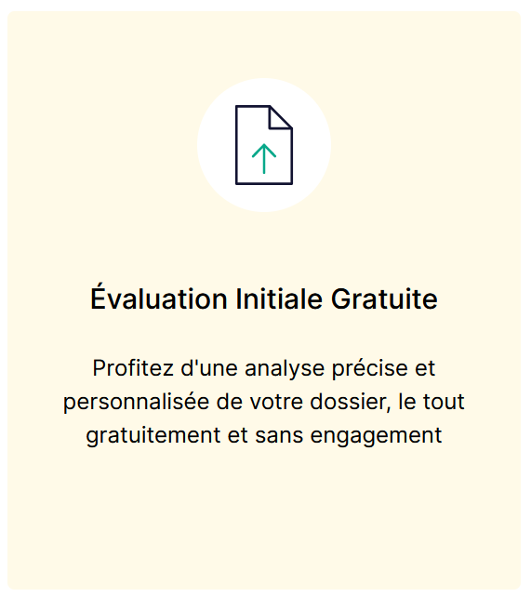
  - Directly Affected Party: I am the person or company directly harmed. (Person silhouette)
  - Lead Representative I was harmed, and I'm representing a group with the same issue. (Group silhouette)
  - Authorized Representative: I handle legal and financial matters for someone else's claim. (Document & signature icon)
  - Trusted Person: I'm a legal professional or authorized association (per the law of July 1, 1901). (Shield & checkmark icon)
Routing Logic:
- Authorized Representative/Trusted Person:
  - Message: "Welcome! As an authorized representative or trusted person, you'll have special access. To expedite the setup, please tell us how to contact you:"
  - Options: Email, Telephone ([Text Box])
- Buttons:
- Save & Continue
- Save and resume later

PAGE 4: YOUR INFORMATION
Heading: Help Us Build Your Case: Start with Your Information
- Section 1: Individual or Company?
  - Radio Button: Individual
  - Radio Button: Company
If 'Individual' is selected:
- Section 1a: Your Details
  - First Name: (Text field,)
  - Last Name: (Text field,)
  - Address: (Text Field, integrate address API for auto-population)
  - Phone Number: (Text field)
  - Email: (Text field,)
If 'Company' is selected:
- Section 1b: Your Company Details
  - Company Registration Number: (Lookup field connected to API)
  - Company Name: (Auto-filled from API)
  - Company Address: (Auto-filled from API)
  - Legal Representative: (Auto-filled from API)
  - Your First Name: (Auto-fill from web form)
  - Your Last Name: (Auto-fill from web form)
  - Your Position in the Company: (Text field)
If the first name and last name do not match the legal representative, ask:
  - Are you authorized to act on the company's behalf?
    - Radio Button: Yes
      - Authorization Type: (Dropdown)
        - Corporate Officer
        - Legal Director
        - Special Representative
        - Provisional Administrator
        - Ad Hoc
    - Radio Button: No
      - Legal Representative's Email: [Text Box]
      - [Button] Send Request for Delegation of Signature
Important Notes (Developer):
- Legal Expert Dashboard: Flag cases where the entered name doesn't match the legal representative in the API.
- After 'Send Request' Button: Display the message "Your request is being processed. You can continue, but the form cannot be finalized until authorization is confirmed."
- Buttons:
- Save & Continue
- Save and resume later

PAGE 5: YOUR INFORMATION (CONTINUED)
Heading: Have Legal Support? Let Us Know
- Section 2: Existing Representation?
  - Radio Button: Yes
  - Radio Button: No (Skip to next question if 'No')
- If 'Yes':
  - Organization Type: (Dropdown)
    - Lawyer
    - Collection Agency
    - Legal Funder
    - Other (Please Specify): [Text Box]
  - Name: (Text field)
  - Direct Contact: (Text field)
- Section 3: Legal Insurance/Protection?
  - Tooltip: Legal insurance/protection helps with dispute costs. It might be a separate policy or part of your home, car, or business insurance.
  - Radio Button: Yes
  - Radio Button: No
  - Radio Button: I'm not sure
Routing Logic:
- Directly Affected Party: Go to 'Opposing Party Information'
- Lead Representative Go to ‘Details of Your Group’
- Buttons:
- Save & Continue
- Save and resume later

PAGE 6: DETAILS OF YOUR GROUP
Heading: Tell Us About the Group You Represent
  - How many people do you represent? (Text field)
  - Any represented individuals your married spouse and/or minor children?
    - Radio Button: Yes (Provide fields for their information below)
    - Radio Button: No
  - Did others choose you as their representative?
    - Radio Button: Yes (Provide fields to add their information below)
    - Radio Button: No (Message: ‘Submit for yourself only. Add others later via e-mandate request from your dashboard’.)
Required Fields for each individual:
- First Name: (Text field)
- Last Name: (Text field)
- Email Address (Valid?): (Text field)
- Phone Number (Valid?): (Text field)
- Address (Auto-fill): (Text field, integrate address API)
Important Note (Developer): Pop up to inform Lead Representative that a GDPR consent document will be emailed for electronic signature to each party they represent.
Message : “GDPR Consent Required
Important: To proceed with your group's case, we need the electronic consent of each individual you represent. This ensures we comply with data protection laws and can process their information.
What to do:
- Inform your group members: Let them know to expect an email with a GDPR consent document.
- Ask them to check their spam: The email might land in their spam folder.
- Ensure they sign the document: Their signature is crucial for us to proceed.
Why is this important?
Consent allows us to legally process their personal information, essential for a thorough case evaluation. Without consent, we cannot proceed with their claims.“
Developer Instructions: Trigger the GDPR consent email automatically for represented parties (exclude spouse and children).
- Buttons:
- Save & Continue
- Save and resume later

PAGE 7: OPPOSING PARTY INFORMATION
To help us investigate, please provide details about the opposing party.
- Section 1: Type of Opposing Party
  - Radio Button: Individual
  - Radio Button: Company
If 'Individual' is selected:
- Section 2a: Individual Details
  - First Name: (Text field)
  - Last Name: (Text field)
  - Address: (Text field, integrate address API for auto-population)
  - Phone Number (optional): (Text field)
  - Email (optional): (Text field)
If 'Company' is selected:
- Section 2b: Company Details
  - Company Registration Number: (Lookup field connected to API)
  - Company Name: (Auto-filled from API)
  - Company Address: (Auto-filled from API)
  - Legal Representative: (Auto-filled from API)
- Section 3: Contact Information
  - Direct Contact Name (if different from Legal Representative): (Text field)
  - Direct Contact Email: (Text field)
  - Direct Contact Phone Number: (Text field)
- Buttons:
- Save & Continue
- Save and resume later

PAGE 8: PROCEDURAL STATUS
Required fields marked with (*).
I will provide legal definitions later for the (?) as tooltips
Let's assess your situation! Tell us how pressing your claim is and what you hope to achieve.
- Section 1: Initial Status
  - Radio Button: I have not taken any steps yet (*)
    - If selected, display:
      - Reason for Inaction: (Text Area)
  - Radio Button: I have initiated an amicable claim (*)
    - If selected, display:
      - Date of Claim: (Date Field, *)
      - Radio Button: Have you received a response? (*)
        - If 'Yes', display:
          - Next Step: (Dropdown: Seeking Counsel, Negotiation, Litigation)
  - Radio Button: I have obtained a first-instance decision (*) (?)
    - If selected, display:
      - Date of Decision: (Date Field, *)
      - Court: (Text Field, *)
      - Radio Button: Are you satisfied with the decision? (*)
        - If 'No', display:
          - Next Step: (Dropdown: Seeking Counsel, Negotiation, Litigation)
- **Radio Button: I am involved in an appeal procedure (*) (?)
  - If selected, display:
    - Date Appeal Filed: (Date Field, *)
    - Appeal Court: (Text Field, *)
    - Radio Button: Do you know the primary legal ground for appeal? (*)
      - If 'Yes', display:
        - Select the primary legal ground for appeal: (*) (?)
          - Dropdown Menu Options:
          - Error of Law (?)
          - Error of Fact (?)
          - Procedural Error (?)
          - Abuse of Discretion (?)
          - Other (Please specify)
        - Description of the legal ground: (Text Area)
- Section 2: Additional Information
  - Tooltip: This section aims to gather any factual evidence or information that is relevant to the case and might help to evaluate your compensation.
  - Do you already have a Lawyer?
    - First Name: (Text field, *)
    - Last Name: (Text field, *)
    - Address: (Text field, integrate address API)
    - Email: (Text field, *)
    - Phone Number: (Text field)
  - Important Case Elements: (Please list and briefly describe any important elements of your case. These could include Expert Reports (?), Witness Testimonies (?), Photos or Videos (?), Documents (?): (Text Area - Description: )
  - Expectations and Objectives: (Text Area)
  - Uphold documents Option

- Button: Submit

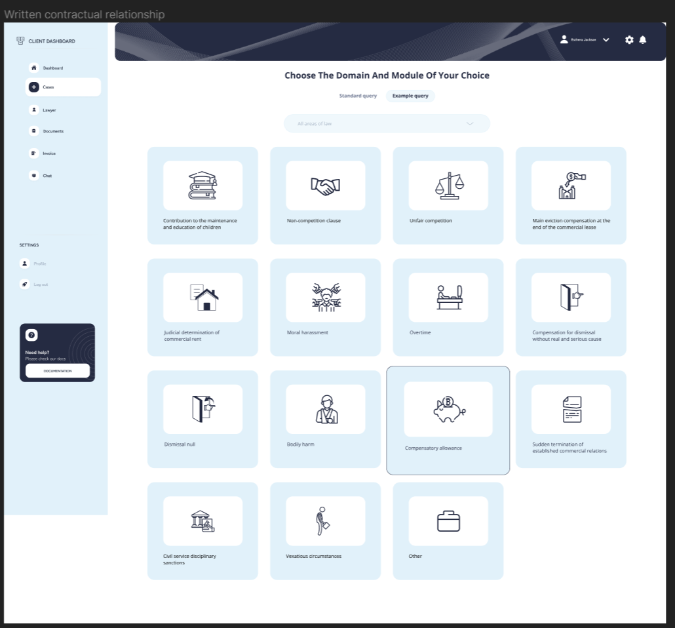
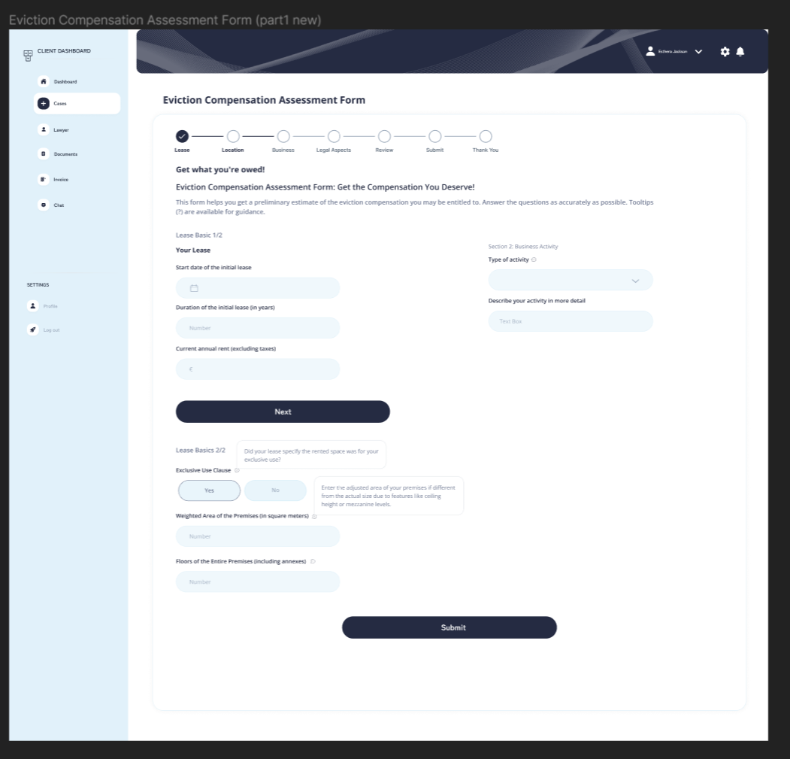

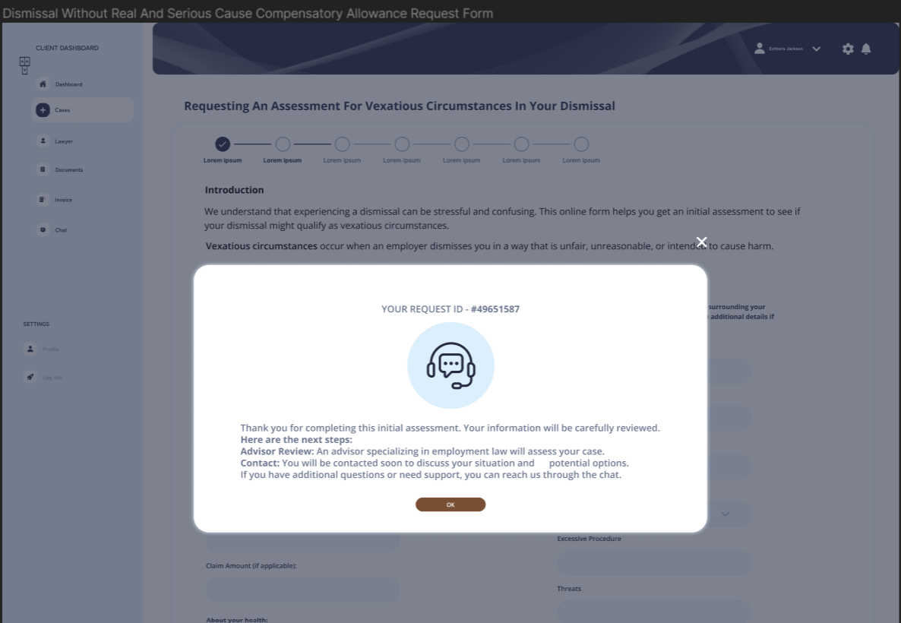

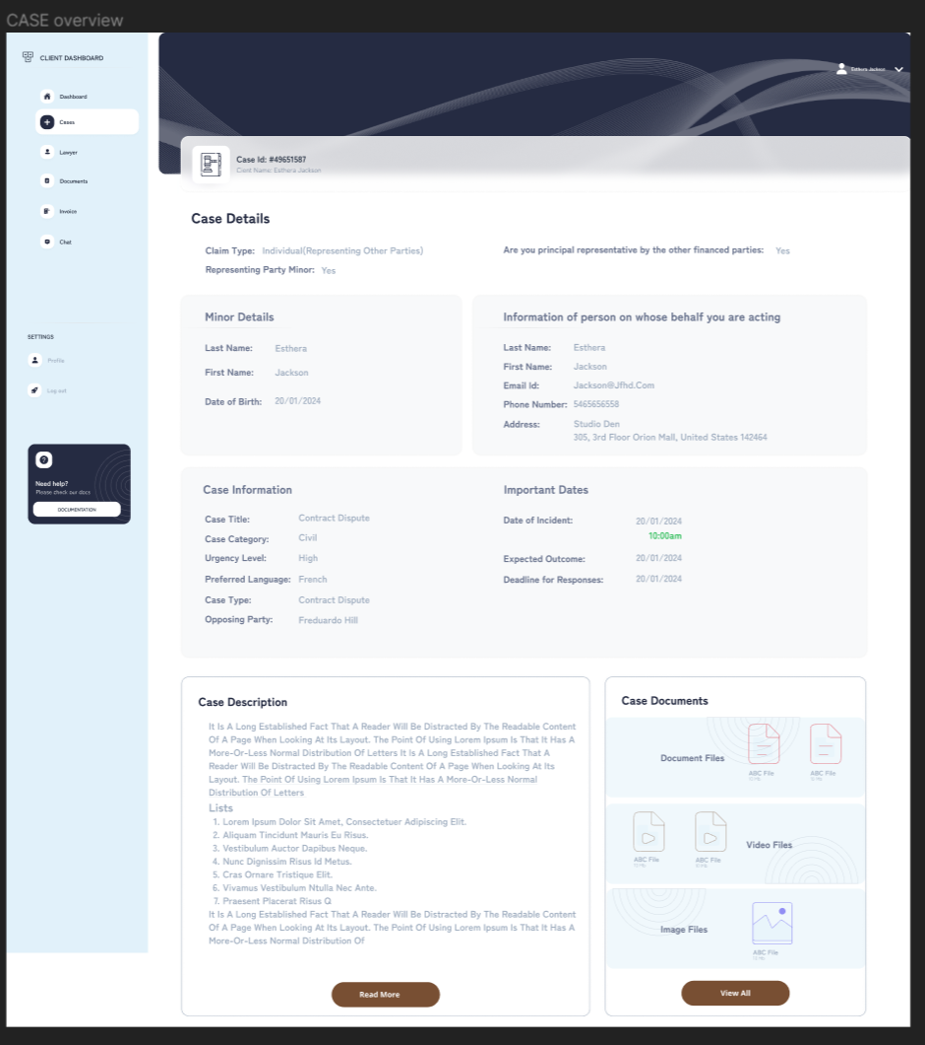

We need to rethink the design of the last screen. I'll work on it.
Here is a first example :

Dashboard
Airier, easier to use. Look modern and dynamic. Focus on the main information. Can apply to all categories of clients, not only those who represent minor or other plaintiffs, etc.
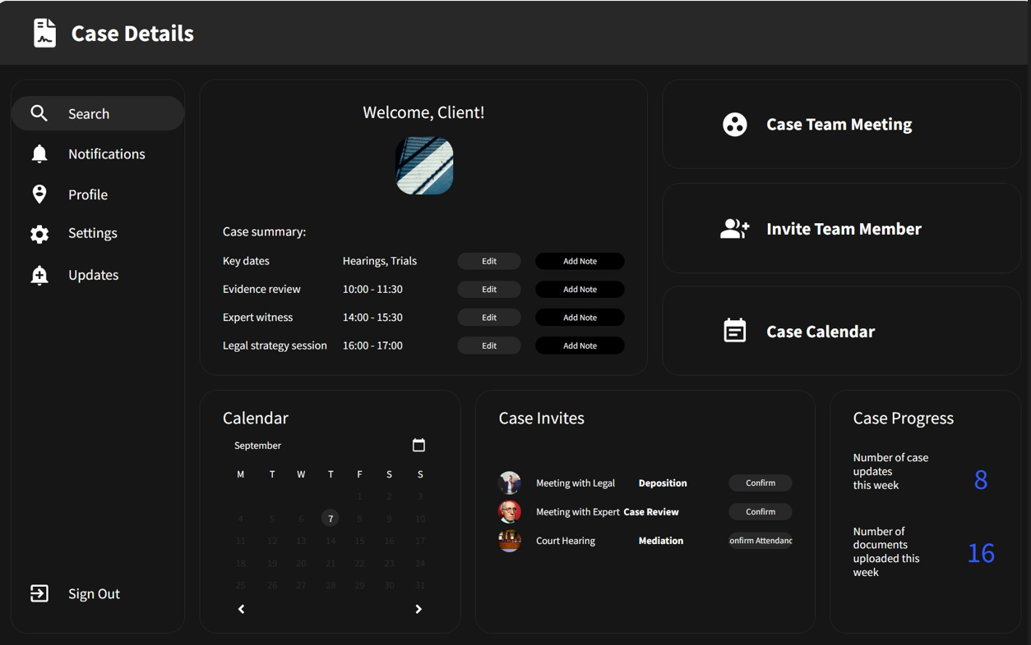

Timeline

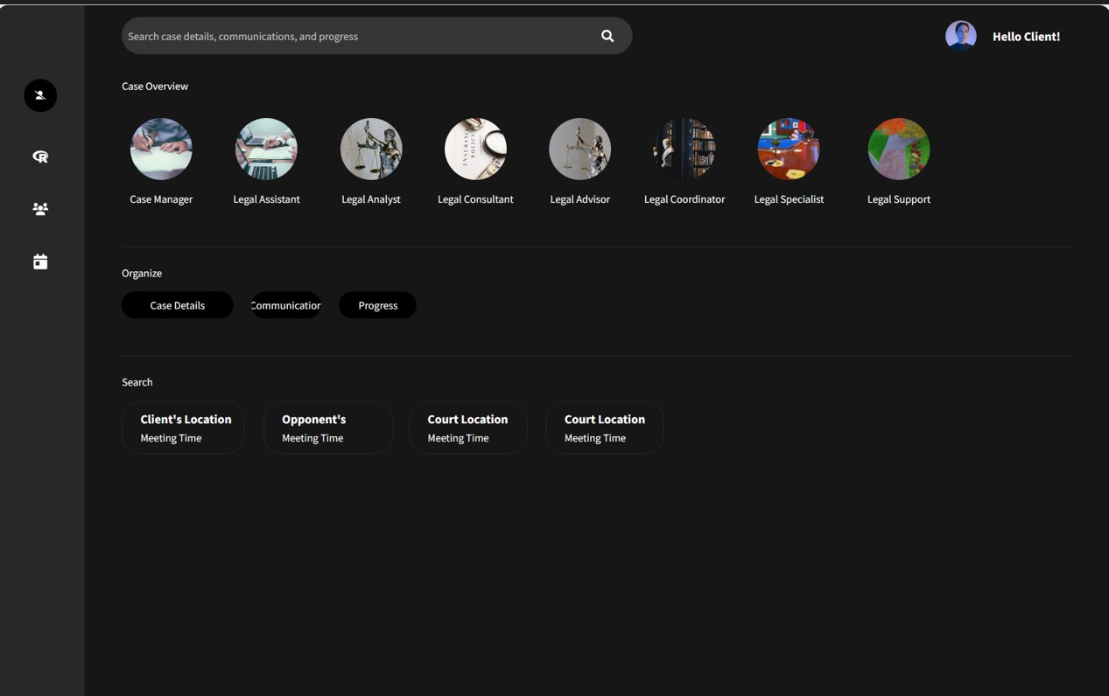

Notifications on left, explaining cards on the right
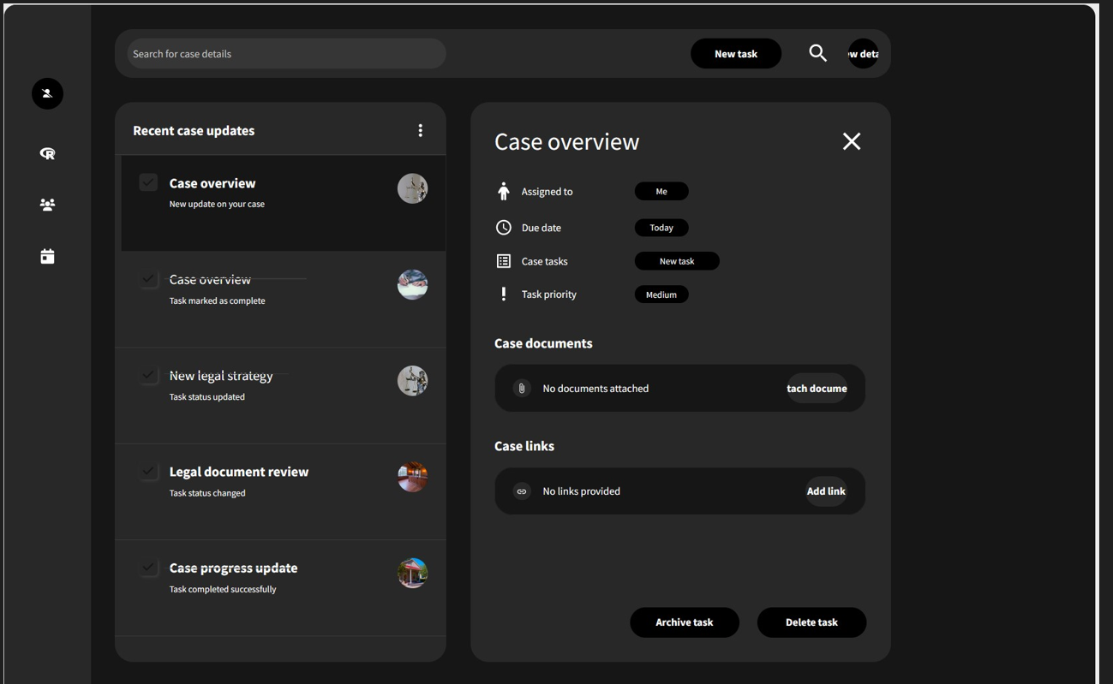

Clear Visual on peronnal information a documents
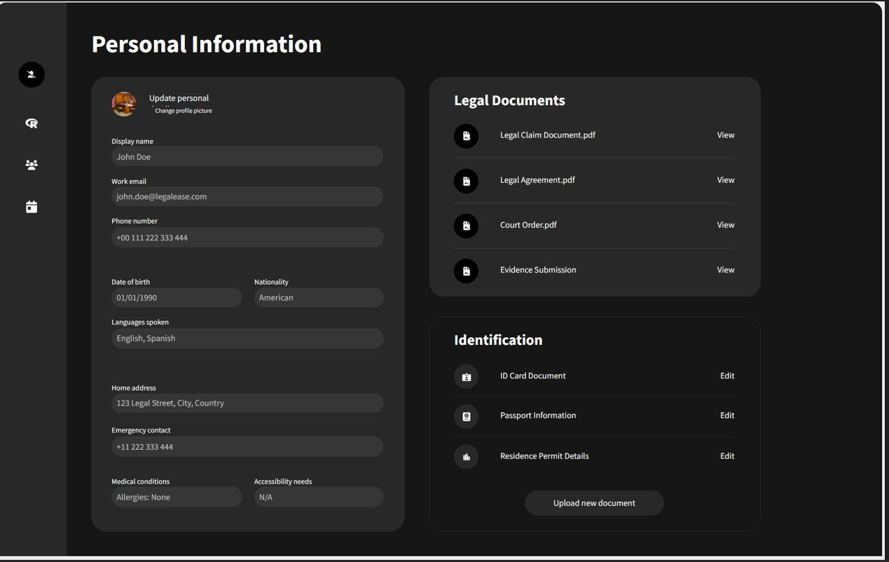

Settings
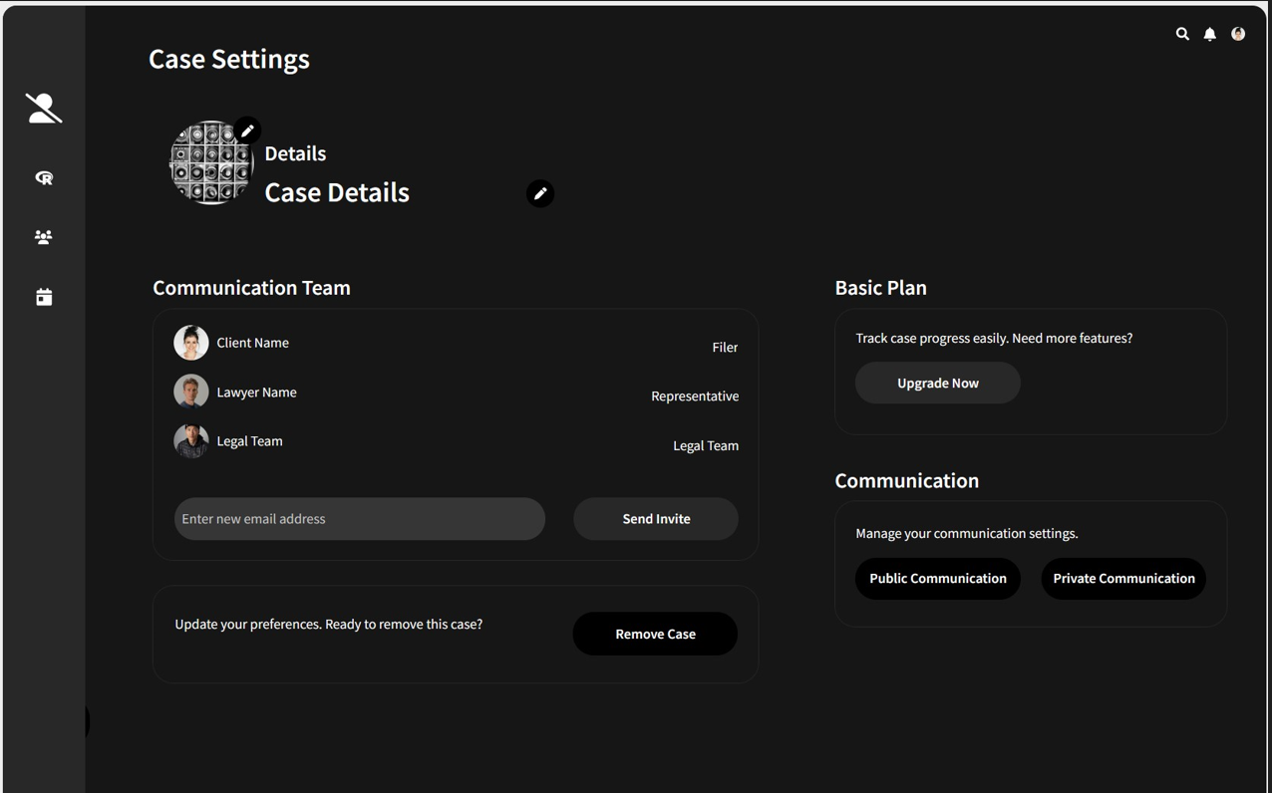

Of course, there are elements that need to be reviewed and you can choose a completely different style. I do it in a few minutes with the AI assistant Uizard.

