Steps for connection and updation of files to the server:

Step 1 : First you to download a FTP software that is basically used for file transfer between one system to another. We are using Filezilla software for that. There are many other software also.

Step 2 : After you successfully download the Filezilla you have to configure your FileZilla FTP client.
- Select File → Site manager (CTRL+S) from the menu bar:
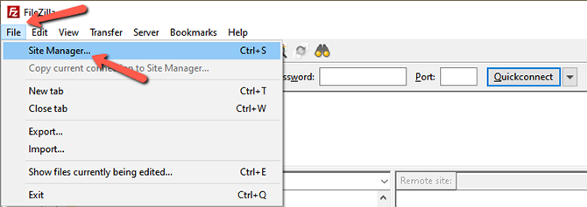

- This is the panel where you can enter information about your website. There are two available options:

- New Site - You can use this option to create the data for your website.
- New Folder -You can use this option if you add more than one website and you wish to group some of them together.
- Enter the name of the new folder and then click on New Site.
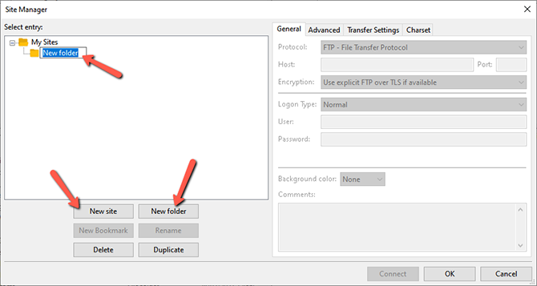

- Enter your FTP Hostname, port, choose the protocol, logon type, user and password.
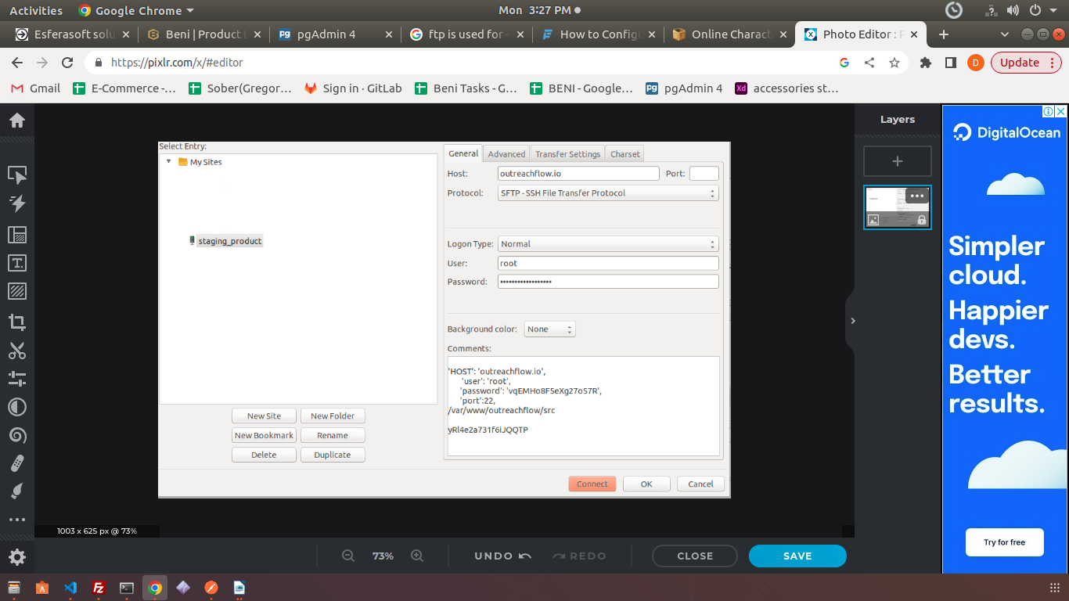

- If you are having key.pem file then you have to set you settings like this:
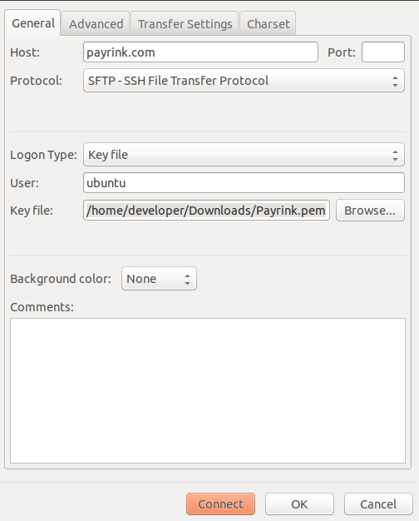

Key file is the path where you file is located. Set it as your location.

Step 3 : After you have confiugre all the settings the press on the click button this will connect your FTP to the server. This will also create shortcut that will allow you to connect to your website on the server with a click of a button.

Step 4: During connect if you got any popup for the unknown host key then press the ok button.
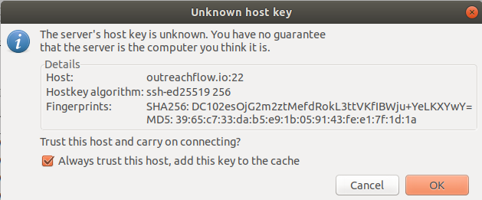

Step 5 : After you successfully connected you have will get something like this.
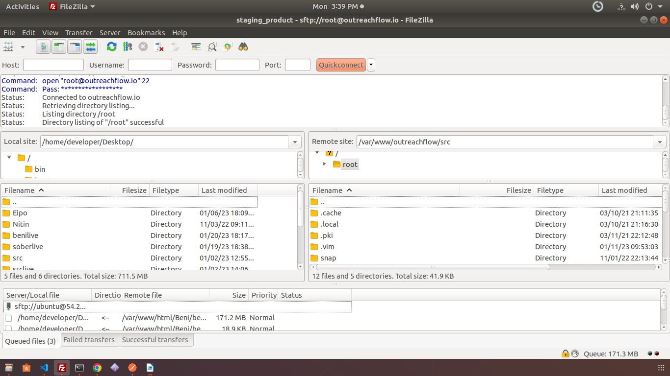

At the right side you can see the files that are present in your server. There is a remote site option also you have to enter you path where your project is located and hit enter. This will lead to your project directory.

Step 6 : Then you can navigate to the folders and files. To open any file you have to right click on that file there is a option of view/edit just click on that and that file will be open in you editor.

Step 7: After the changes in the file you have to save that file and come back to that filezilla it will display you a pop up just click on yes and you file will be saved to the server.
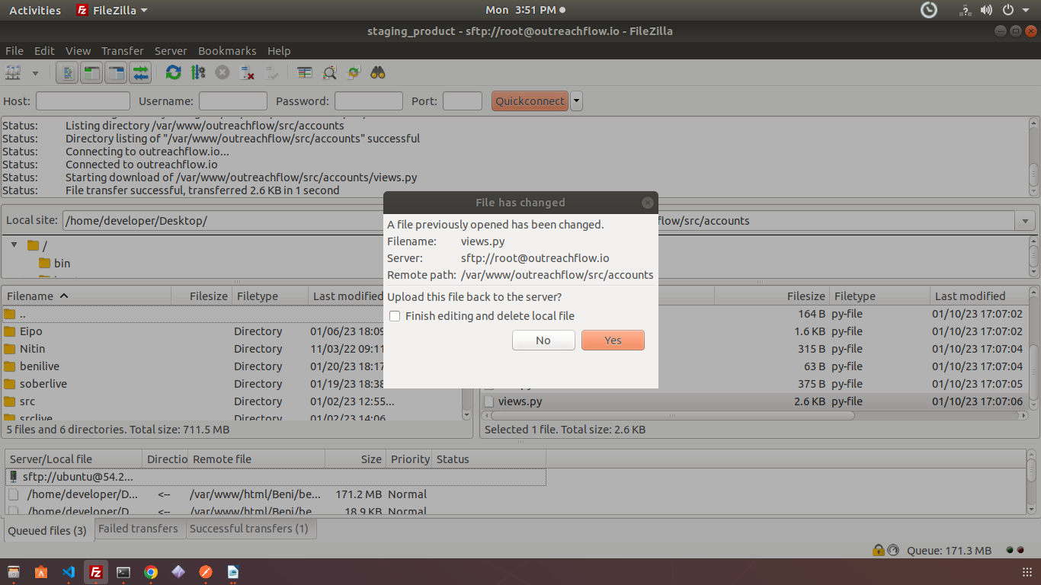

Step 8 : At last you have to restart you apache server to see the changes on the server.

To restart you server go to the terminal and write this command : ssh root@outreachflow.io
In this command root is you user and outreachflow.io is your hostname.

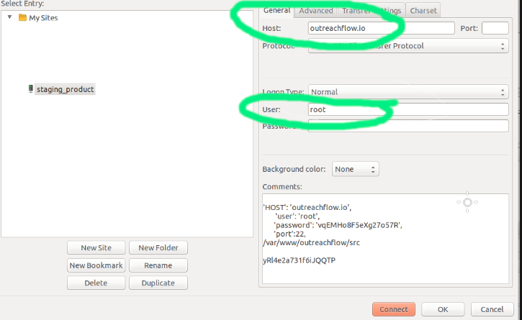

After you enter this command it will ask you to enter you password. You have to enter the password same as you used while the connection. After you enter your password hit enter.

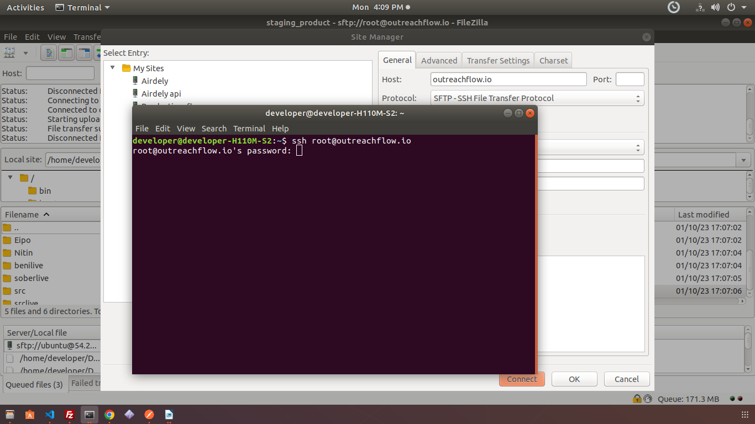

After entering your password you will get a welcome message this means you have connected successfully to your sever.

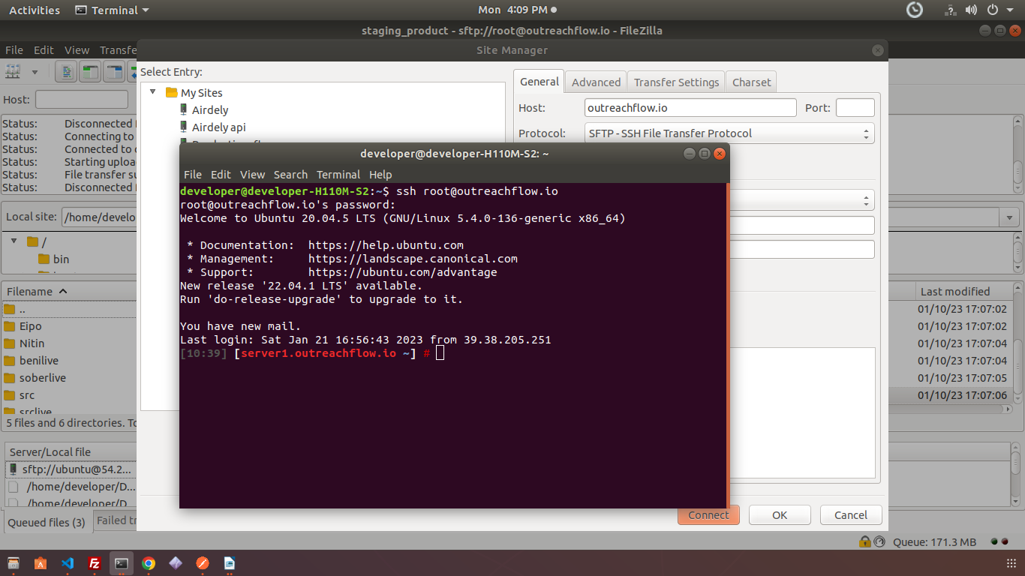

And at last you have to execute this command service apache2 restart. This will restart you apache server and your changes will be reflected on the server.

