Non-Compete Assessment Form

Bug Report

19/07/2024

Basic Information
Question: you can add “.” “,” between numbers, as a separator (revenue, salary). Will this be a problem if we want all numbers to be in the same format? Is it possible to apply a universal format rule with an automatic space after the third, sixth, etc. digit?

Step 2:

- For what reasons was the non-compete clause included in the agreement? (Select all that apply)
Checkboxes: Protecting trade secrets ⓘ (Tooltip: Confidential business information that gives the company a competitive advantage, e.g., formulas, processes, customer lists.),

Client relationships ⓘ (Tooltip: Established connections with customers or clients that the company wants to protect.)

- Which activities are prohibited by the non-compete clause? (Select all that apply)

- What is the geographical scope of the clause? Does the geographical restriction apply to:
• Multi-departmental:
If selected, display “To which departments does the non-compete clause apply?:[ text field where the client can enter multiple department numbers]

[SAVE & CONTINUE] [CLEAR] [EXIT]

Alleged Violation
If "Starting a similar business" is selected, the following fields appear: * What is the name of the new business? * What type of business is it? *
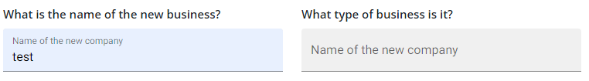
Error in microcopy under “What type of business is it?” Should be Type of business

When was the new business started? [Date picker] Add a Calendar button

Impact and Additional Details
CONDITIONAL LOGIC IS MISSING:
[If Employee is selected:]
- How has the non-competition clause negatively affected you? (Check all that apply) [Checkboxes: Limited job offers, Financial hardship, Stress/anxiety, Other (please specify)]

[If Employer is selected:]
How has the alleged violation of the non-compete clause affected your business? (Check all that apply)

ⓘ (Tooltip: The disclosure or use of your confidential business information by a former employee.). This tooltip only applies to Loss of trade secrets

[Both Employer and Employee:]

Please provide any other details relevant to your situation (e.g., specific clauses in the contract, circumstances of termination): [Text area] Not Mandatory

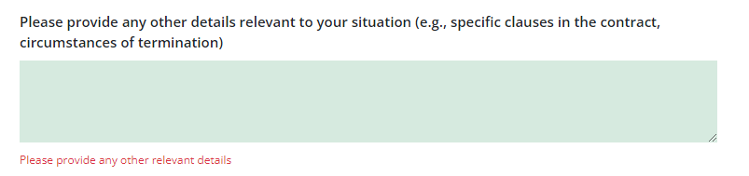

I need to be able to relaunch the form by selecting employees to verify the information below.

Basic Information
Modification for employee
- Duration of Employment (in years): Enter the total number of years you were employed at the company. [Input: Number] How many months did you work at the company? Microcopy “Total number of months”
- Last Monthly Salary (before deductions, in €): Enter your last gross monthly salary before any deductions. What was your last gross monthly salary before any deductions? Microcopy €
- End Date of Employment: When did your employment officially end? [Date Picker] Block calendar for the future.
- Job Title Select your job title from the list, or specify if it's not listed. What was your job title?
- Employment Type Indicate whether your employment was full-time, part-time, or contract-based. Was your employment full-time, part-time, or contract-based?

Impact and Additional Details
CONDITIONAL LOGIC IS MISSING:
[If Employee is selected:]
- How has the non-competition clause negatively affected you? (Check all that apply) [Checkboxes: Limited job offers, Financial hardship, Stress/anxiety, Other (please specify)]

