GENERAL MODIFICATIONS :
- “Financing Request” Title: Delete this title from all the title pages in the form. Replace with a title relevant to the specific page, as provided.
- Start with a free case evaluation: Delete this sentence form all the pages of the form.
- Replace all the buttons at the end of the page: 
By “Previous” and “Next” (in this order)
When the customer clicks on 'Previous', the previous page is loaded with all the data entered retained. If the customer then clicks on 'Next' again, the previously entered data is still preserved.
- For all phone numbers, preselect France as the prefix

PAGE 1: Replace « Finance request » by « Welcome”

PAGE 2: Replace « Finance request » by « Data Privacy

Change text to
“Your privacy is our top priority. All information you share with us is kept strictly confidential and used solely for the evaluation of your case. We employ robust security measures to protect your data and never share it without your explicit consent.

To learn more about our commitment to safeguarding your privacy, please review our comprehensive Privacy Policy [View our Full Privacy Policy link] “

- Buttons:
- Previous
- Next

PAGE 3: Replace « Finance request » by « Tell us your role”
- Delete Heading: Tell Us Your Role as it is a title
- Cards with visual cues: Add the right icons
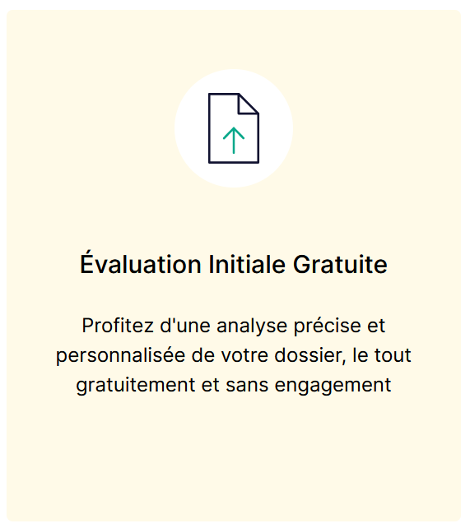
  - Directly Affected Party: (Person silhouette)
  - Lead Representative: (Group silhouette)
  - Authorized Representative: (Document & signature icon)
  - Trusted Person (Shield & checkmark icon)
Routing Logic:
- Authorized Representative/Trusted Person:
  - Message: "Welcome! As an authorized representative or trusted person, you'll have special access. To expedite the setup, please tell us how to contact you:"
  - Options: For Telephone preselect France
  - Buttons : Submit
  - N.B : Special access: Develop this later as a separate phase/form for attorneys, business referrals, and associations, with the service client on the line. After verifying their legal information and understanding how they will use our platform, I will gather their specific needs to provide the best possible presentation of the platform. Then, I will create personalized access to their dashboard, which will include details such as the number of clients they represent and the number of cases they handle, especially if they wish to register as a lawyer for our service. So, the form stops there for them.
The form continues for Directly affected Party and Lead Representative.
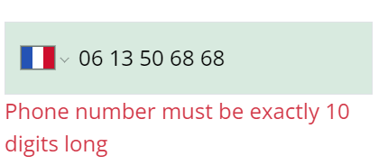
Contrary to what is indicated in the error message, the phone number entered is 10 digits longs, whereas to continue the form I had to enter 9 numbers. Error may come from the international code +33. Anyway 10 digits is the correct number.
Finally, I can either skip this step by selecting a country and entering 9 digits, or not select a country and enter 10 digits. These two options are not good.
However, the functionality works correctly on the next screen for Individual.

- Authorized Representative/Trusted Person:
  - Buttons:
  - Previous
  - Next

PAGE 4: Replace « Finance request » by “Your Information”
If 'Individual' is selected:
- Section 1a: Your Details
  - Address: (Text Field, integrate address API for auto-population)
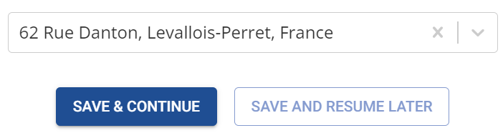

The postal code should be displayed (92300 Levallois-Perret). It is an Important information for auto-completion of legal doc, or choice of the jurisdiction, statistics, etc.. Furthermore, once you have selected an address, the cross for delete doesn’t work.
Also, it should be a mandatory field. For now, you can skip to next screen without filling it.

If 'Company' is selected:
- Section 1b: Your Company Details
Only company registration number should be displayed.
  - Company Registration Number: (Lookup field connected to API)
If there is a verification issue with the API, a popup will appear with the message: 'We were unable to recognize your company. Please provide your phone number and/or email address so we can contact you directly.' This will be followed by fields for entering a phone number and an email address.
If the company number is verified, the following field should be automatically filled:
  - Company Name: (Auto-filled from API)
  - Company Address: (Auto-filled from API)
  - Legal Representative: (Auto-filled from API)
Then, client must then filled:
  - Your First Name: (Auto-fill from web form)
  - Your Last Name: (Auto-fill from web form)
  - Add Phone number field : Mandatory
If the first name and last name do not match the legal representative, ask:
  - Your Position in the Company: (Text field)
The position company question should only appear if the name and last name do not match the legal representative (name and last name)
  - Are you authorized to act on the company's behalf?
    - Radio Button: Yes
    - Radio Button: No
      - Legal Representative's Email: [Text Box]
      - [Button] Send Request for Delegation of Signature
      - Wrong Pop Up Message display the following message " Your request is currently being processed. You may continue to navigate the platform, but please note that we cannot proceed with your case until we have received and confirmed the necessary authorization
For now the message is :
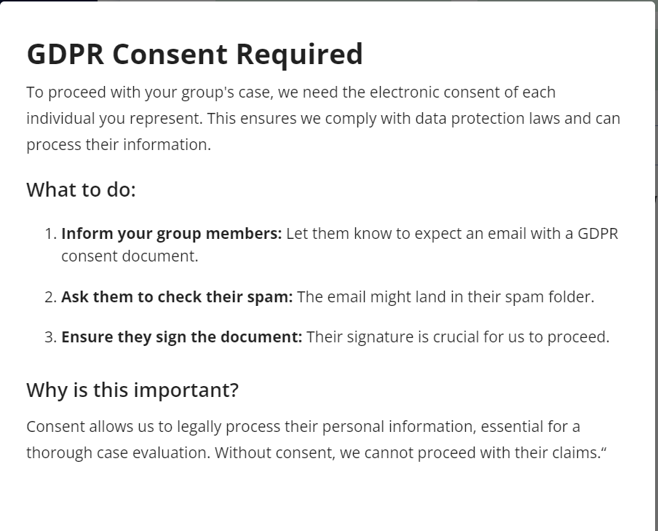
Important Notes (Developer):
- Legal Expert Dashboard: Flag cases where the entered name doesn't match the legal representative in the API, even though the client says he is authorized to act on behalf of the company so the legal expert know that he has to control the authorization

- Buttons:
- Previous
- Next

PAGE 5: Replace « Finance request » by “Legal Support »
Heading: Do you already have legal support? Let us know!
- Section 2: Do you currently have legal representation for your case?
- If 'Yes':
  - Organization Type: (Dropdown)
  - Name: (Text field)
  - Direct Contact: two fields: Field email and Field phone number.
Mandatory: at least one of the two fields must be completed. One filed is enough.
- Section 3: Do you have any legal insurance or protection coverage?
  - Radio Button: Yes
    - If yes : Could you please provide the details of your legal insurance or protection coverage ? (Answers are not mandatory):
      - Insurance provider:
      - Policy number
      - Coverage limits

PAGE 6: DETAILS OF YOUR GROUP
Heading: Tell Us About the Group You Represent
  - How many people do you represent? (Text field)
  - Do any of the represented individuals include your married spouse and/or minor children under your parental authority?
Tooltip Parental authority: Legal rights and responsibilities to make decisions and take actions on behalf of your minor children
    - Radio Button: Yes (Provide fields for their information below)
Name
Surname
Date of birth
Button Add Another Person
Name
Surname
Date of birth
Button Add Another Person, etc.
    - Radio Button: No
  - Did others choose you as their representative?
    - Radio Button: Yes (Provide fields to add their information below)
Fields are ok but apply API for the address
Presently, if you don’t type in the country, you can’t Save & Continue
    - Radio Button: No
Tooltip is not complete. The complete message is: “Submit for yourself only. Add others later via e-mandate request from your dashboard”

Important Note (Developer): Pop up to inform Lead Representative that a GDPR consent document will be emailed for electronic signature to each party they represent. The pop up did not appear.
Message : “GDPR Consent Required
Important: To proceed with your group's case, we need the electronic consent of each individual you represent. This ensures we comply with data protection laws and can process their information.
What to do:
- Inform your group members: Let them know to expect an email with a GDPR consent document.
- Ask them to check their spam: The email might land in their spam folder.
- Ensure they sign the document: Their signature is crucial for us to proceed.
Why is this important?
Consent allows us to legally process their personal information, essential for a thorough case evaluation. Without consent, we cannot proceed with their claims.“
Developer Instructions: Trigger the GDPR consent email automatically for represented parties (exclude spouse and children).
- Buttons:
- Previous
- Next

PAGE 7: OPPOSING PARTY INFORMATION
To help us investigate, please provide details about the opposing party.
If 'Individual' is selected:
- Section 2a: Individual Details
the error messages for the fields are missing
Apply Adress API
email and phone number fields are optional
If 'Company' is selected:
the error messages for the fields when wrongly completed are missing
- Section 2b: Company Details
Same method as in page 4 for Company.
If we can’t recognize the company, same message.
- Section 3: Contact Information
All Contact Information Fields are optional in section 3
- Buttons:
- Previous
- Next

It is not possible to save and continue

PAGE 8: PROCEDURAL STATUS – (could not control, because impossible to continue)
Required fields marked with (*).
I will provide legal definitions later for the (?) as tooltips
Let's assess your situation! Tell us how pressing your claim is and what you hope to achieve.
- Section 1: Initial Status
  - Radio Button: I have not taken any steps yet (*)
    - If selected, display:
      - Reason for Inaction: (Text Area)
  - Radio Button: I have initiated an amicable claim (*)
    - If selected, display:
      - Date of Claim: (Date Field, *)
      - Radio Button: Have you received a response? (*)
        - If 'Yes', display:
          - Next Step: (Dropdown: Seeking Counsel, Negotiation, Litigation)
  - Radio Button: I have obtained a first-instance decision (*) (?)
    - If selected, display:
      - Date of Decision: (Date Field, *)
      - Court: (Text Field, *)
      - Radio Button: Are you satisfied with the decision? (*)
        - If 'No', display:
          - Next Step: (Dropdown: Seeking Counsel, Negotiation, Litigation)
- **Radio Button: I am involved in an appeal procedure (*) (?)
  - If selected, display:
    - Date Appeal Filed: (Date Field, *)
    - Appeal Court: (Text Field, *)
    - Radio Button: Do you know the primary legal ground for appeal? (*)
      - If 'Yes', display:
        - Select the primary legal ground for appeal: (*) (?)
          - Dropdown Menu Options:
          - Error of Law (?)
          - Error of Fact (?)
          - Procedural Error (?)
          - Abuse of Discretion (?)
          - Other (Please specify)
        - Description of the legal ground: (Text Area)
- Section 2: Additional Information
  - Tooltip: This section aims to gather any factual evidence or information that is relevant to the case and might help to evaluate your compensation.
  - Do you already have a Lawyer?
    - First Name: (Text field, *)
    - Last Name: (Text field, *)
    - Address: (Text field, integrate address API)
    - Email: (Text field, *)
    - Phone Number: (Text field)
  - Important Case Elements: (Please list and briefly describe any important elements of your case. These could include Expert Reports (?), Witness Testimonies (?), Photos or Videos (?), Documents (?): (Text Area - Description: )
  - Expectations and Objectives: (Text Area)
  - Uphold documents Option

- Button: Submit

