Hi Mridulla,
I will be unreachable on Monday but will be available again on Tuesday.
- I’ve incorporated the changes in this document, and the connection/chat, which functionality needs to work better.
- We’ve been making more or less only adjustments, and it was my fault for frequently changing the text last year.
- I would like to finalize the setup now. We will slowly start inviting organizations next year and provide more functionality options.
I need a small milestone from you:
- Fix the chat/connection feature (I’ve simplified it further).
- Implement the changes listed below.
- By the end of this year, I will provide the final text updates. After that, we should have a perfect, error-free B2B network.
Let’s complete the website.
The change:
4
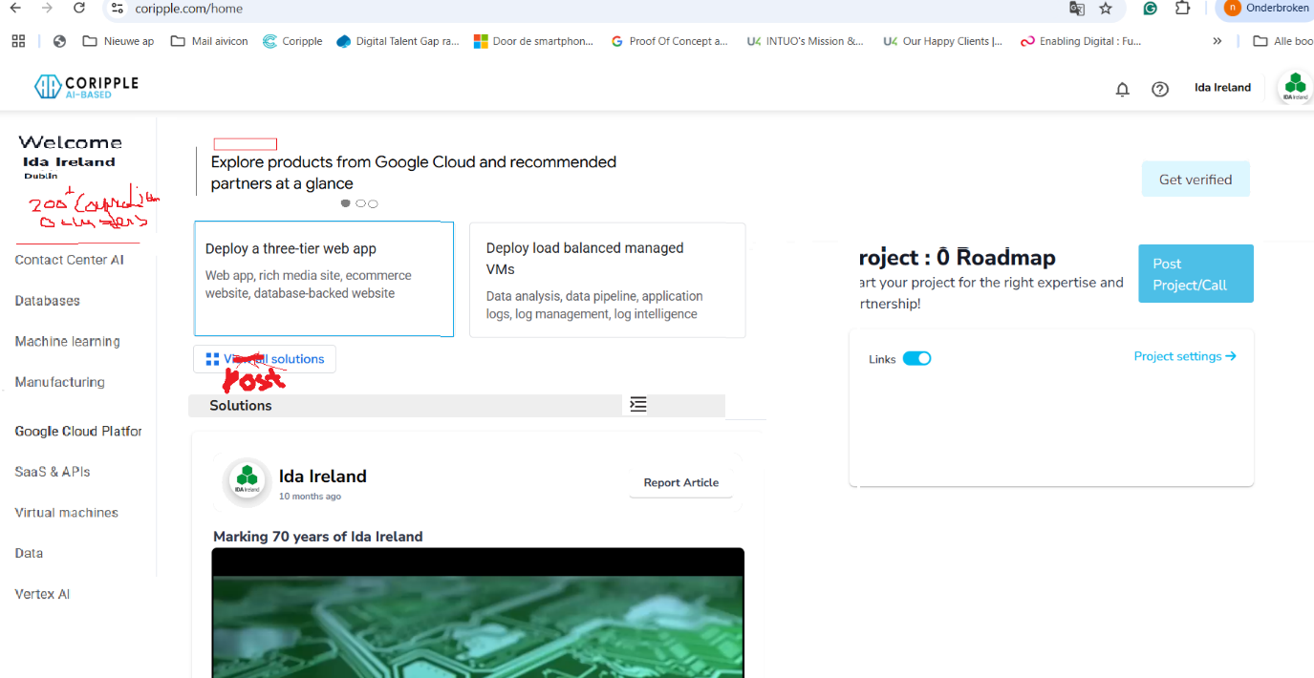
8
7
6
5
3
2
1
- Let's create a menu on the right side that displays "Welcome", along with the company name and location.
- There's no need anymore for connections box on the right anymore. 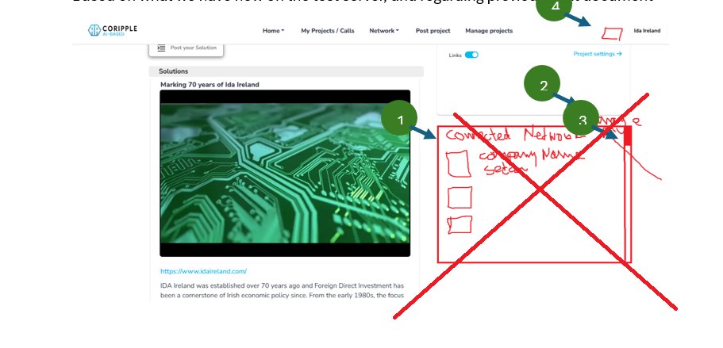 Instead, just display the number of connections and, for now 0 clusters, show this below the company name

- For the menu on the left:
  - Use simple grey text with a small grey line on the right side.
  - This setup will allow us to easily add more links later, such as groups, clusters, and events.
Menu items:
- Profile Page
- Projects/Calls
- Analytics
- R&D Institutes
- Investors & Acceleration
- Post Project/Call
- Manage your Project
- Manage your network

- The question mark should turn yellow, and indicate the three notifications, update profile, setup criteria, and verify organization.
- Update Your Profile:
The platform restricts access for profiles that are not fully updated. Please ensure your profile is complete to gain full access.
- Personalization:
Set up your criteria so the platform can help you find the right B2B connections.
- Get Verified:
After successful verification, a label will appear on your profile, for trust with current and future B2B relationships.

- The notification bell highlights in red when there is a new invite or chat message.
- Notifications are still displayed, but you now need to scroll through them horizontally (left to right).

- The feed should be moved up, so once notifications are cleared, the feed shifts to the top of the page and scrolls like LinkedIn.

The two buttons, along with their corresponding text (which appears when a button is clicked), are now placed within separate boxes. This results in having two distinct boxes.

- The right box should move up, with the feed section.

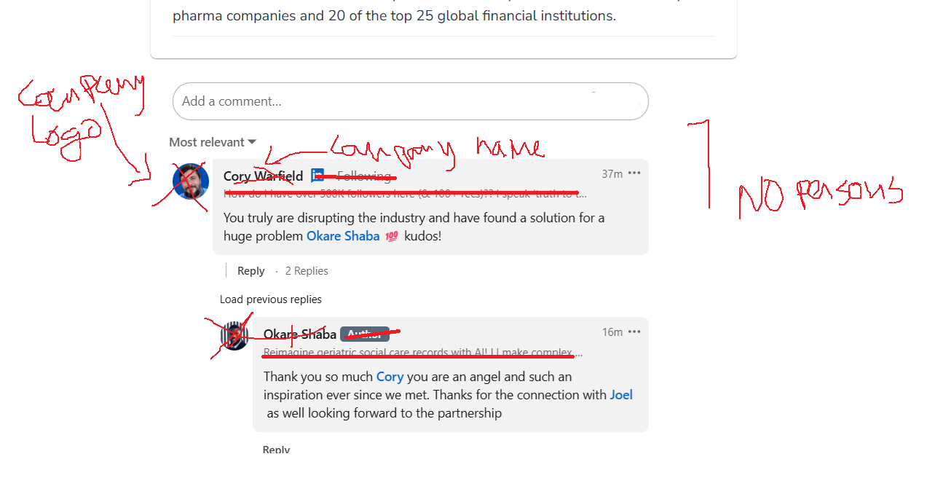
9
- Let's complete our work by allowing users to post comments below the feed posts. There’s no need for likes or smileys. Since organizations reply, not individuals, the organization's logo and name should appear with each comment, not the person’s.
Connection/chat, stays further the same

2
1
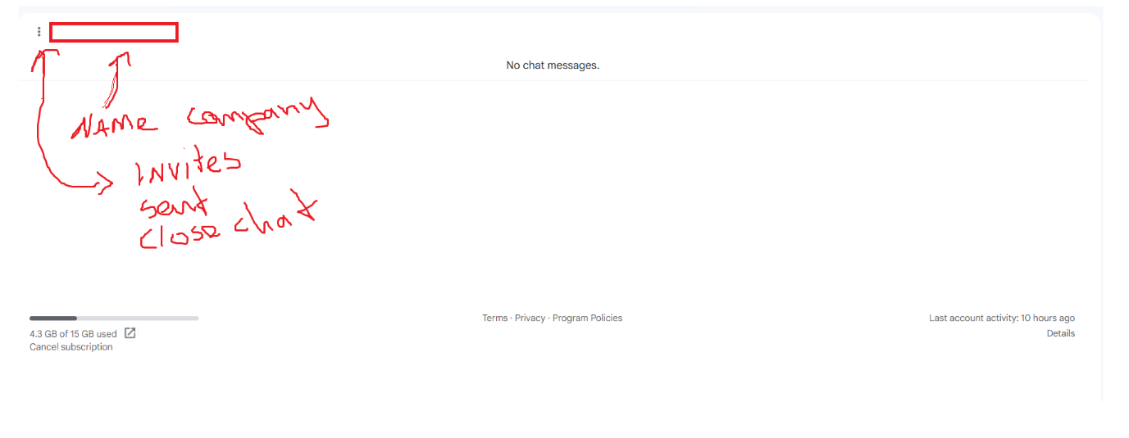
- After the chat is done, I will discuss a change with you. I would like a clean, minimalistic design, which I think can be easily achieved. The chat interface should also be kept minimal.
- In the chat section, display the company name of the organization with which you are chatting.
- There will be a menu icon (three dots). When clicked, the following options will appear:
  - All connections
  - Received invites
  - Sent invites
  - Close chat

- Companies can choose to remain anonymous.
- If a company opts not to stay anonymous, it will appear in the list. The list can be filtered by sector.

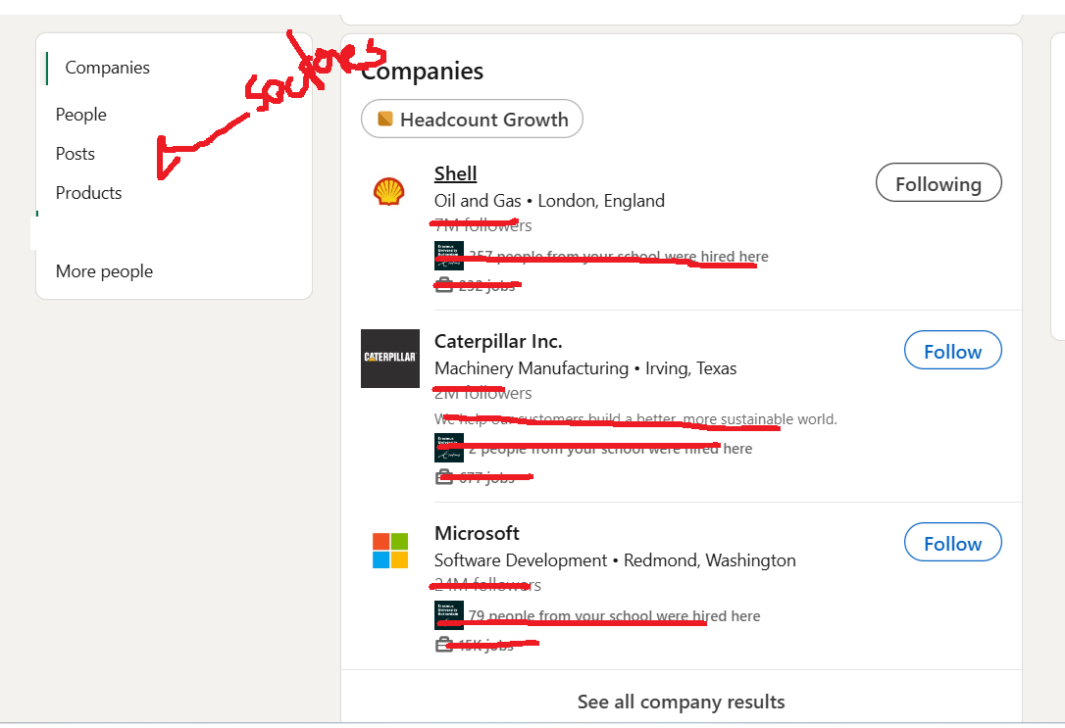
3
1
- Companies appear in the list, which can be filtered by sector.
- In the list, only the company logo, name, and location are displayed—no additional details like total connections.
- A button is available for interaction, which changes states as follows:
- Connect → Pending → Message
- Once connected, a small blue label saying "connected" appears below the "Message" button.
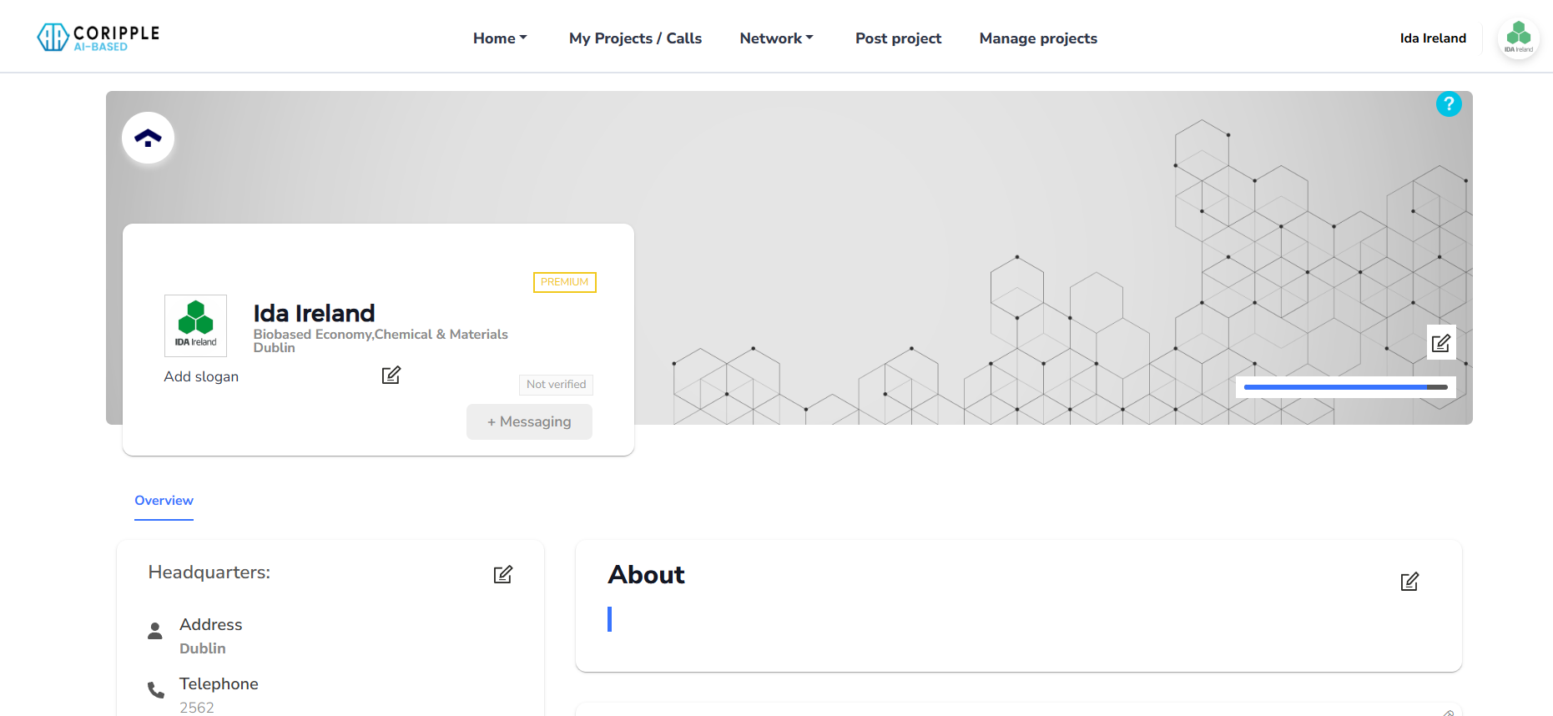
1
- On the profile page, the interaction button follows the same flow:
- Connect → Pending → Message
- Once connected, a small blue label "connected" should appear below the "Message" button.

