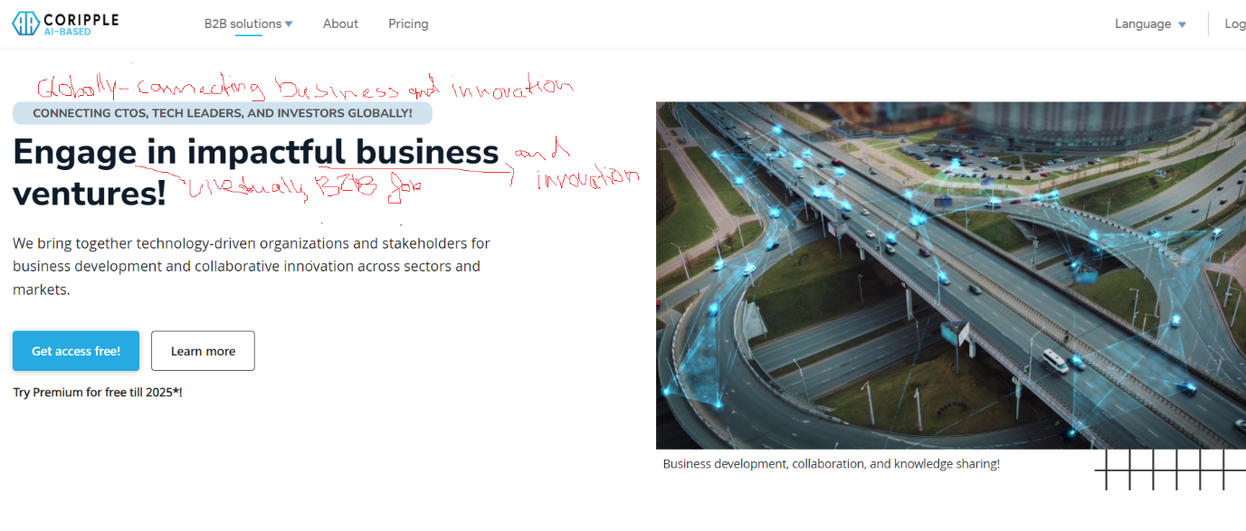
2
1
- Strategic Partnerships & Development
- Get Full Access in 2025 for Free!

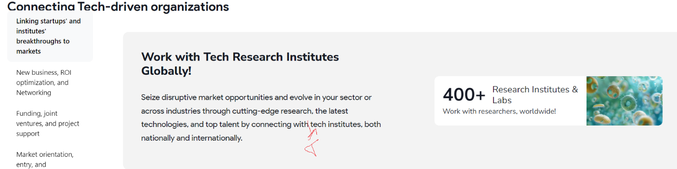
4
3
- Worldwide Network of Research Institutes!
- Connect globally with tech institutes to seize opportunities and evolve with cutting-edge research, technology, and top talent.
1
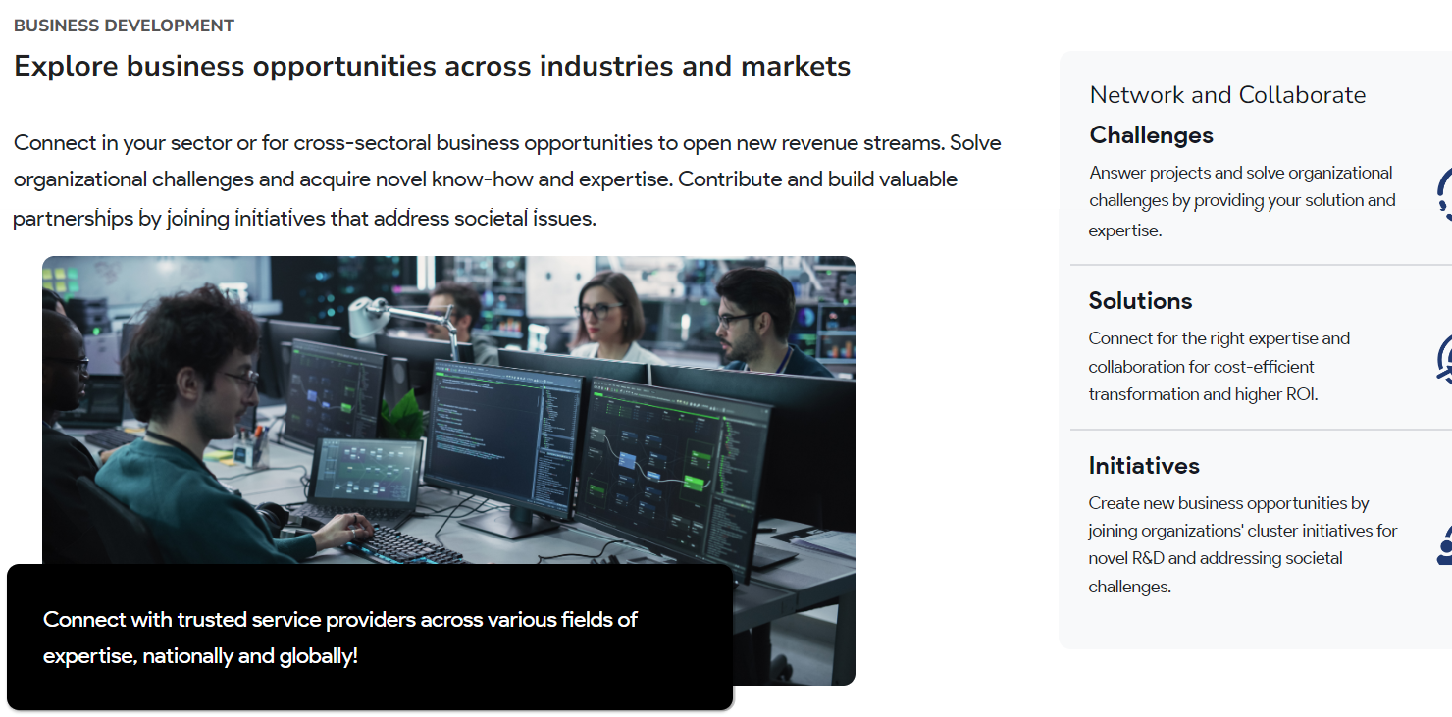
5
4
3
2
- Business Development and Collaboration
- Enable your organization to showcase its solutions virtually to an international B2B audience. Unlock new revenue streams, gain fresh expertise, foster valuable partnerships, and collaborate in clusters to address societal challenges.

Network and Collaborate
- Projects
Overcome organizational challenges and Tackle projects and by offering your solutions and expertise.

- Solutions
Engage with the right experts to drive cost-efficient transformation and maximize ROI through collaboration.

- Initiatives
Unlock new business opportunities by participating in organizational clusters focused on innovative R&D and addressing global societal challenges.
6
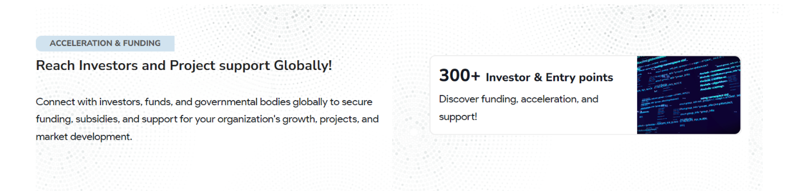
8
7
- An Investor Network
- Access Global Investment Opportunities!
- Connect with investors, funds, and government entities to secure funding, subsidies, and strategic support for your organization’s growth, projects, and market expansion.
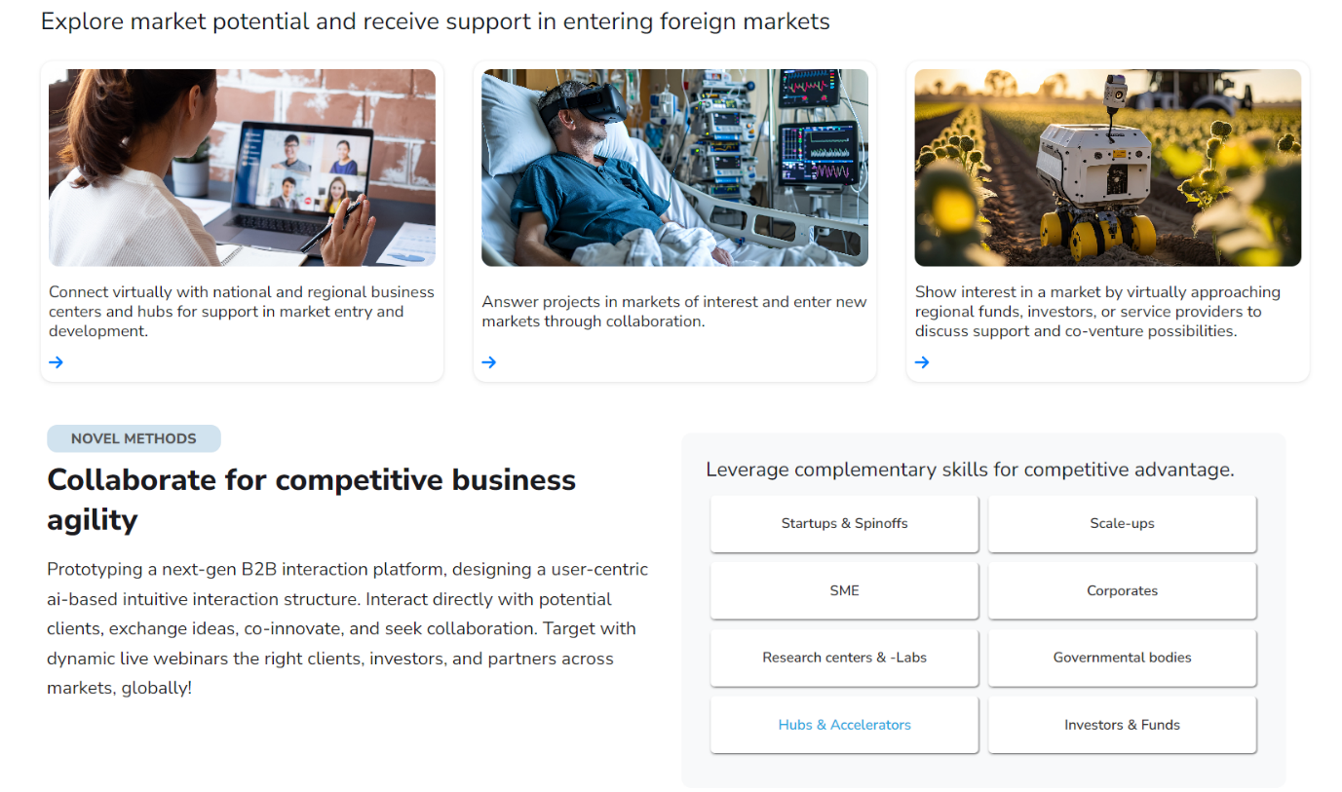
13
12
11
10
9
8
- Explore Global Markets Virtually with Expert Support!
- Connect Virtually with Business Centers for Market Entry and Development Support.
- Engage in projects in target markets and expand through collaboration.
- Gain support from regional funds, investors, and service providers, while exploring co-venture opportunities.

- Utilize complementary skills for an edge.
- Streamlined interaction
- Collaborate for Competitive Agility
- Engage directly with potential clients and complementary partners across sectors, exchange ideas, co-innovate, and foster collaboration to stay ahead in fast-evolving markets.
15
14
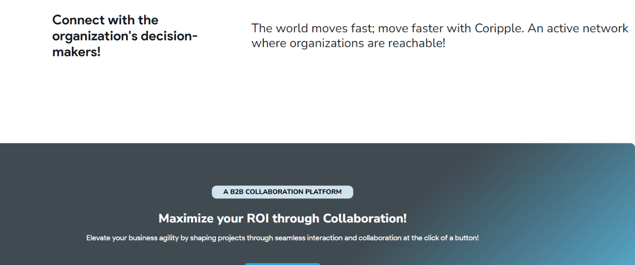
16
- Engage with key decision-makers!
- The world moves quickly—stay ahead with Coripple.

- Boost your ROI with seamless virtual B2B interactions and collaboration—just a click away!
...........
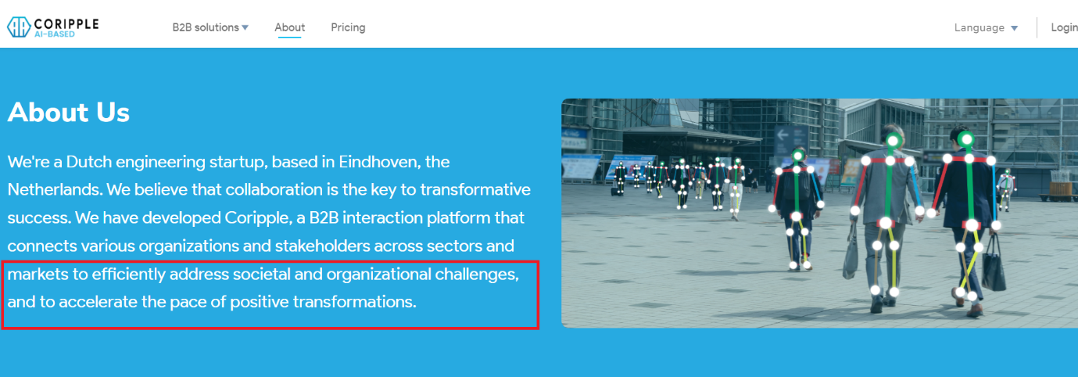
17
- About Us
We are a Dutch engineering startup based in the Eindhoven region, Netherlands. As a diverse international team, primarily composed of dedicated engineers, we are committed to driving positive change through intelligent and efficient virtualization. We have developed Coripple, a platform designed to lay the foundation for seamless and efficient B2B interactions through an intuitive supporting digital infrastructure.
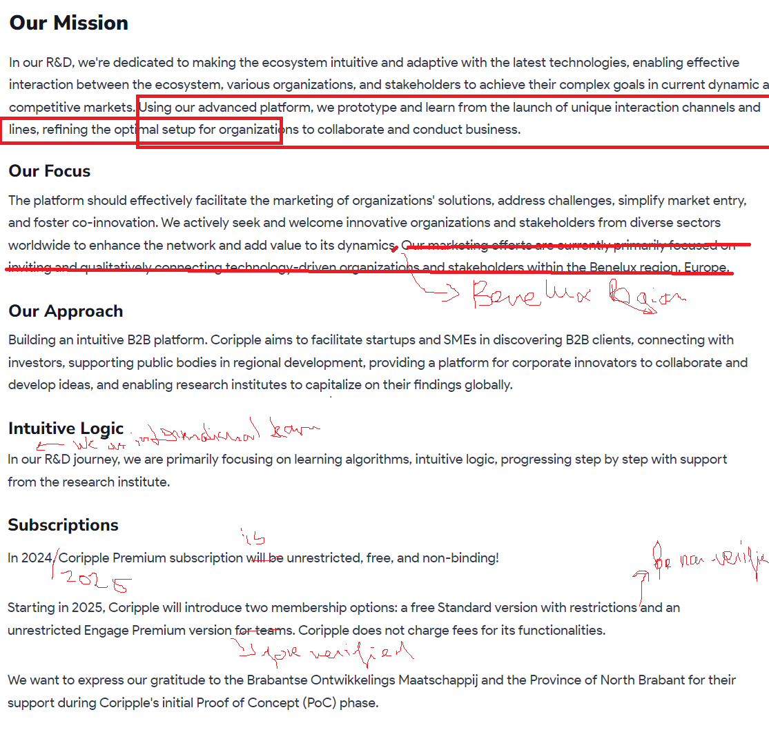
18
16
- Our Mission
At Coripple, we firmly believe that collaboration and direct B2B interaction are the keys to transformative success. Our B2B platform aims to interconnect organizations across diverse sectors, regions, and markets, enabling them to address challenges efficiently and foster growth through innovation and partnership.

Our Focus
The platform is designed to effectively facilitate the marketing of organizations' solutions, address challenges, simplify market entry, and foster co-innovation. We actively approach innovative organizations and stakeholders from diverse sectors worldwide to enhance our network and contribute to its dynamic value.

Our Approach
Building an intuitive B2B platform. Coripple aims to facilitate startups and SMEs in discovering B2B clients, connecting with investors, supporting public bodies in regional development, providing a platform for corporate innovators to collaborate and develop ideas, and enabling research institutes to capitalize on their findings globally.

Intuitive Logic
Our international R&D efforts aim to create an intuitive, adaptive ecosystem powered by the latest technologies. We focus on enabling seamless, intuitive interactions between a learning network, the organization, and stakeholder.

Subscriptions
In 2025, Coripple will be free and non-binding!

Starting in 2026, Coripple will introduce two membership options: a free Standard version with certain restrictions and a free, unrestricted Engage Premium version for verified organizations that have undergone background checks by us. Coripple does not charge fees for its functionalities.

We extend our gratitude to the Brabantse Ontwikkelings Maatschappij and the Province of North Brabant for their invaluable support during Coripple's initial Proof of Concept (PoC) phase.

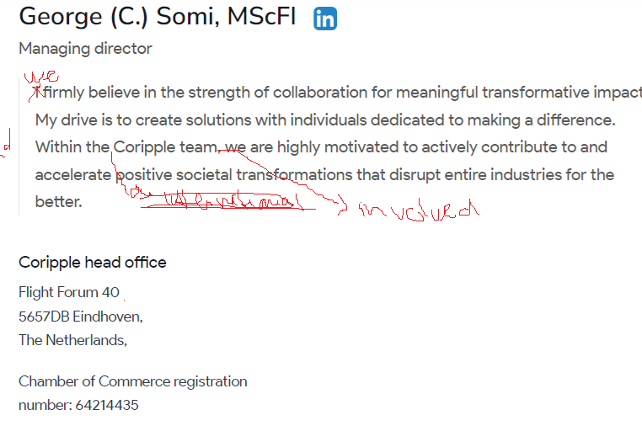
19
- My passion lies in developing solutions alongside individuals committed to making a difference. Together with a team of dedicated engineers, some of whom contribute at no cost, we strive at Coripple to accelerate positive societal transformations, drive growth, and disrupt industries for the better.
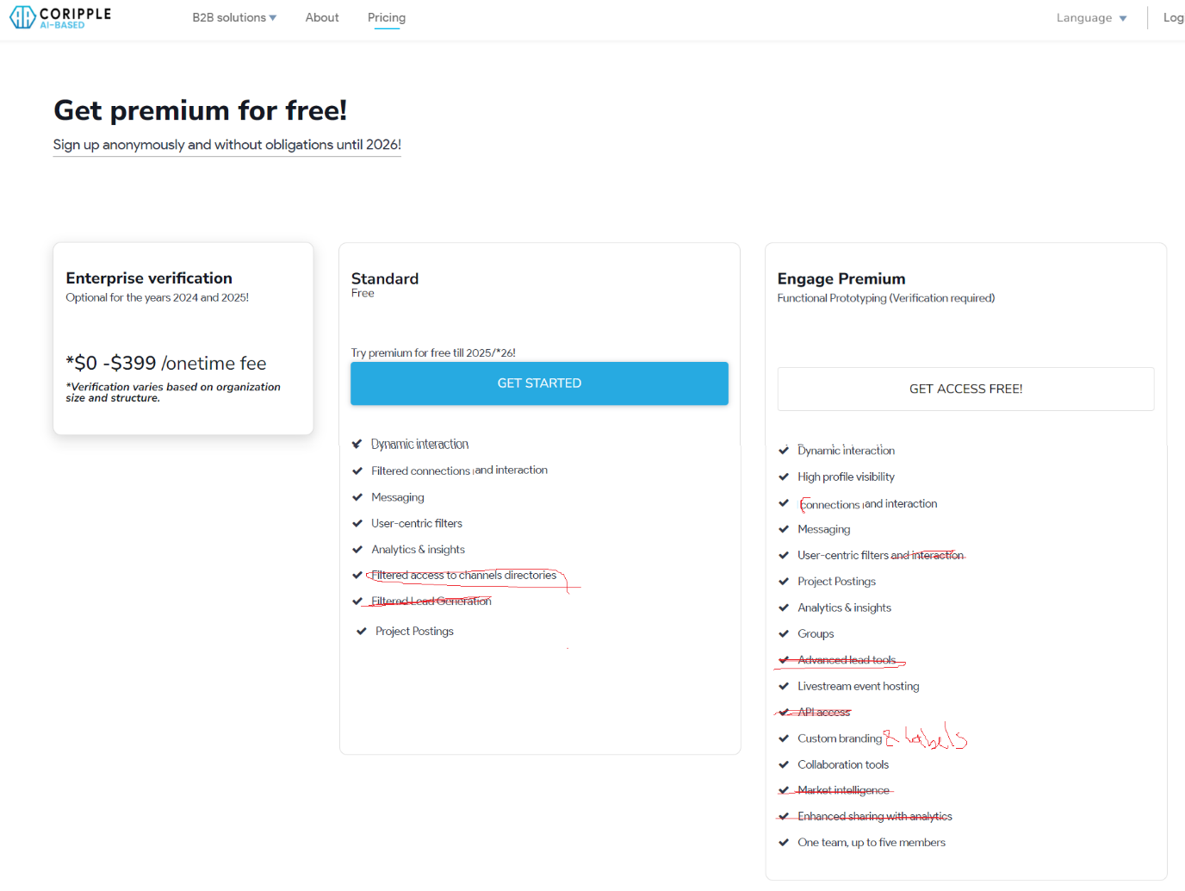
4
3
2
1
- Get free unrestricted access for 2025!
Sign up anonymously and without obligations

- Optional for 2025!

- Standard Account
Free Access

Unlock full access for 2025, with no restrictions!
Get Started
Streamlined B2B Engagement
Connection Requests & Networking
Messaging
User-Centric Filters & Interaction
Analytics & Insights
Filtered Access to Channel Directories
Filtered Lead Generation

- Engage Premium
Unlock Free Access!

Free access in 2025!
Streamlined B2B Interaction
High Profile Visibility
Connection Requests & Networking
Messaging
User-Centric Filters & Interaction
Project Postings
Analytics & Insights
Groups & Clusters
Livestream Event Hosting
Collaboration Tools & Matching
Channel Directories
One Team, Up to Five Members
5
6

- Anonymous, non-binding, and free in 2025.

- How can I register my organization?
To register, just click the "Get Started" button. Complete the required details, and you'll be guided step by step through the registration process.
What will happen after the year 2025 has ended?
In 2026, you will have the option to subscribe to one of our membership plans. You can also choose to cancel your subscription, though we sincerely hope you'll continue to be part of our platform.

https://coripple.com/sales

1
- Showcase your solutions, services, and products directly to potential clients.
2
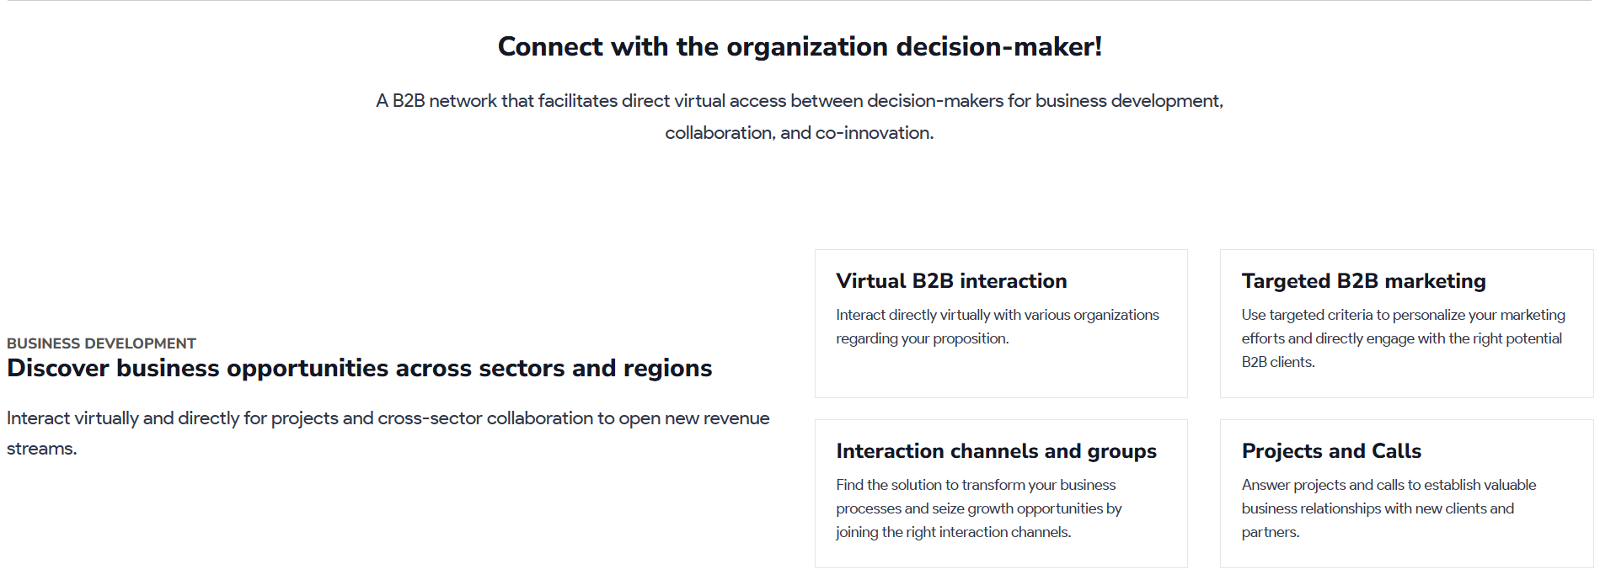
7
6
5
4
3
- A B2B network enabling direct virtual access for decision-makers to foster business development, collaboration, and co-innovation.
- Engage virtually for projects and cross-sector collaboration to unlock new revenue streams.
- Connect directly with organizations to showcase and discuss your proposition.
- Communication channels and networks
Discover solutions to transform your business processes and seize growth by joining the right channels.
- B2B marketing
Personalize your marketing to engage the right B2B clients directly.
- Respond to projects and calls to build valuable business relationships.

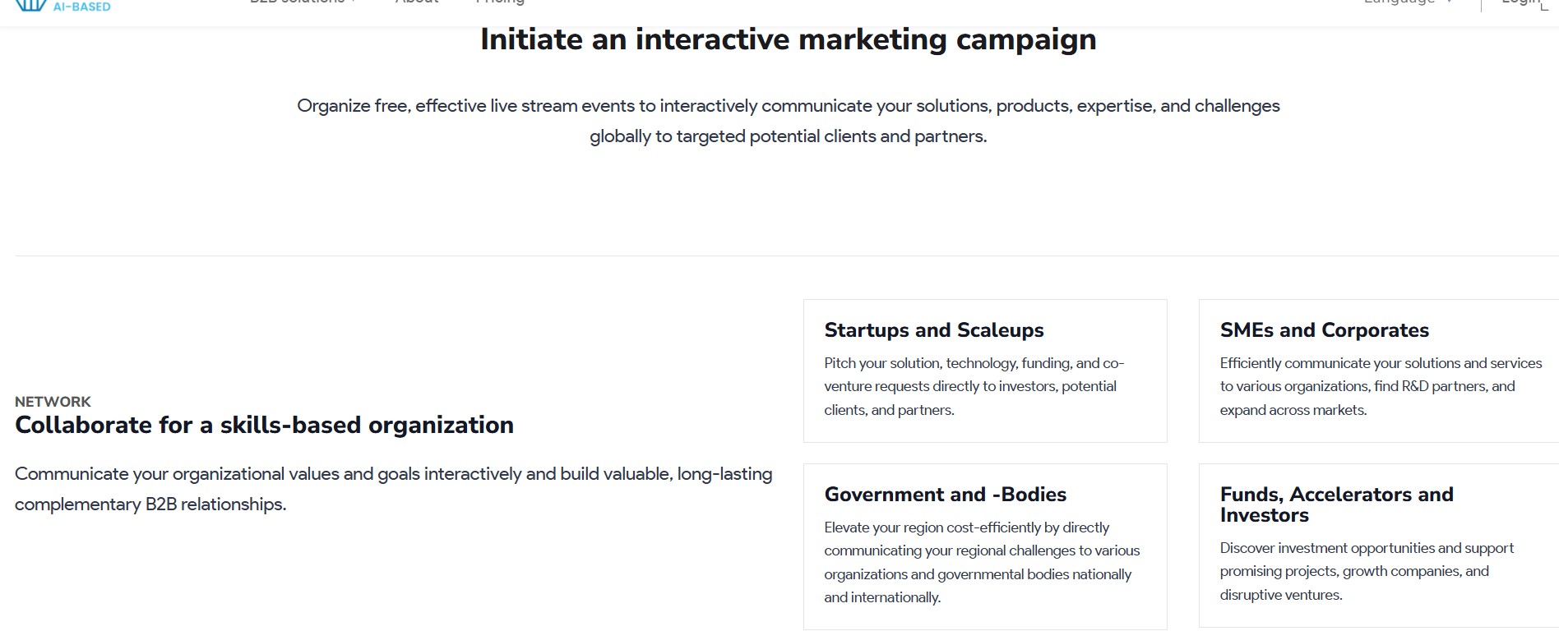
13
9
12
11
10
8
7
- Host free, impactful live streams to showcase your solutions, products, and expertise to global clients and partners.
- Partner to build a skills-driven organization
Communicate your organization's values and goals to build lasting B2B relationships.
- Pitch your solution, technology, and funding directly to investors, clients, and partners.
- Communicate your solutions, find R&D partners, and expand across markets efficiently.
- Elevate your region cost-effectively by sharing challenges with organizations and government bodies locally and globally.
- Connect with key financial and growth support partners for business development.

https://coripple.com/partnerships
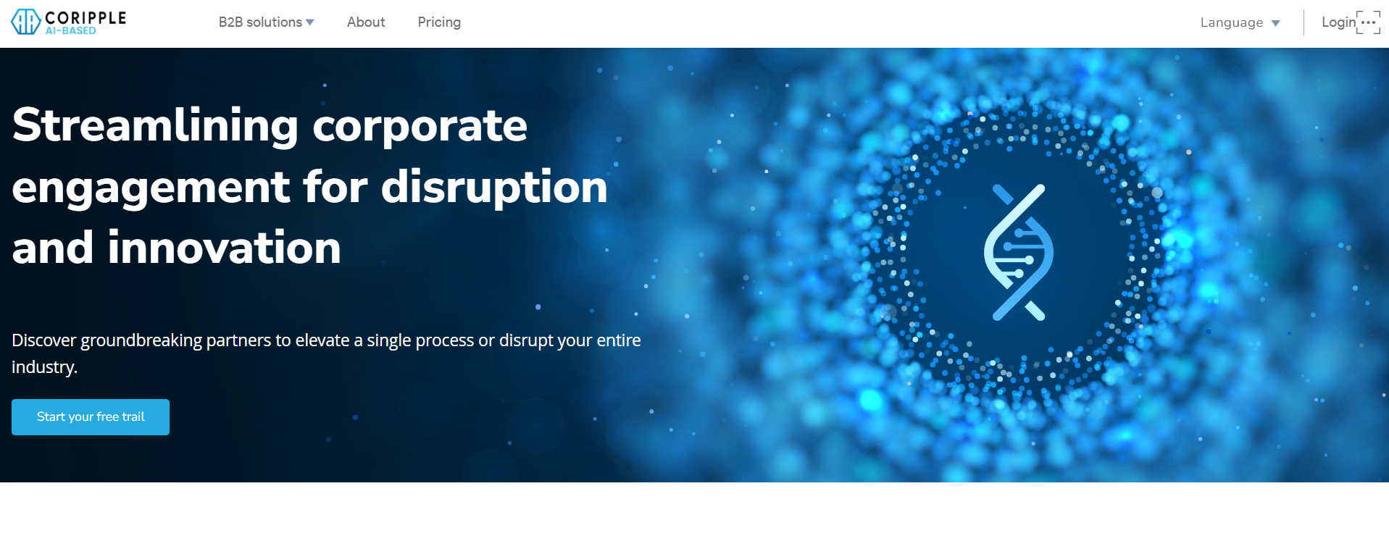
2
1
- Collaboration to drive innovation and disruption
- Find transformative partners to enhance processes or revolutionize your industry.
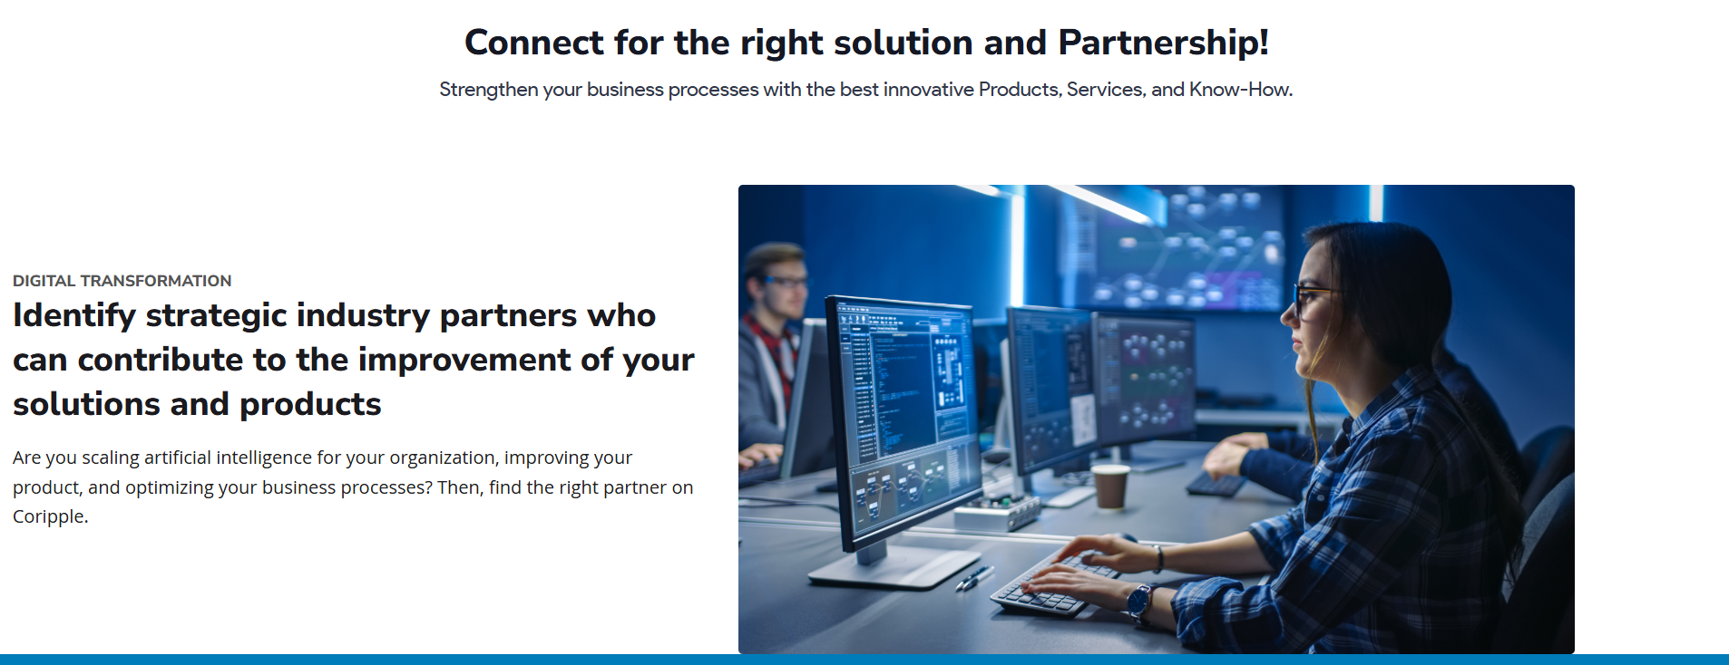
4
3
- The right connections for solutions and partnerships!
Enhance your business with cutting-edge products, services, and expertise!
- Build your strategic partnerships both nationally and internationally
Scaling AI, enhancing your product, and optimizing business processes? Find the right partner on Coripple.

5
- Choose from trusted organizations, SMEs, startups, and spinoffs
Get connected with experts across various specialties, whether established or offering fresh, innovative approaches.
6
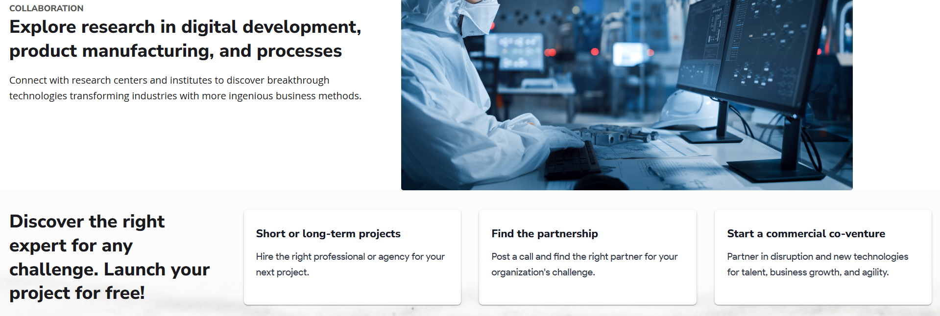
8
7
- Explore research across various disciplines
Connect with research centers and institutes to discover innovative technologies and business methods transforming industries.
- Find the right expert. Start your project for free!
- Short or long-term projects
Find and hire the perfect professional or agency for your next project.
Find the partnership
Post a call to find the ideal partner for your organization's challenge.

Co-venture
Partner for innovation, growth, and agility.


1
- Stay ahead!

https://coripple.com/investments
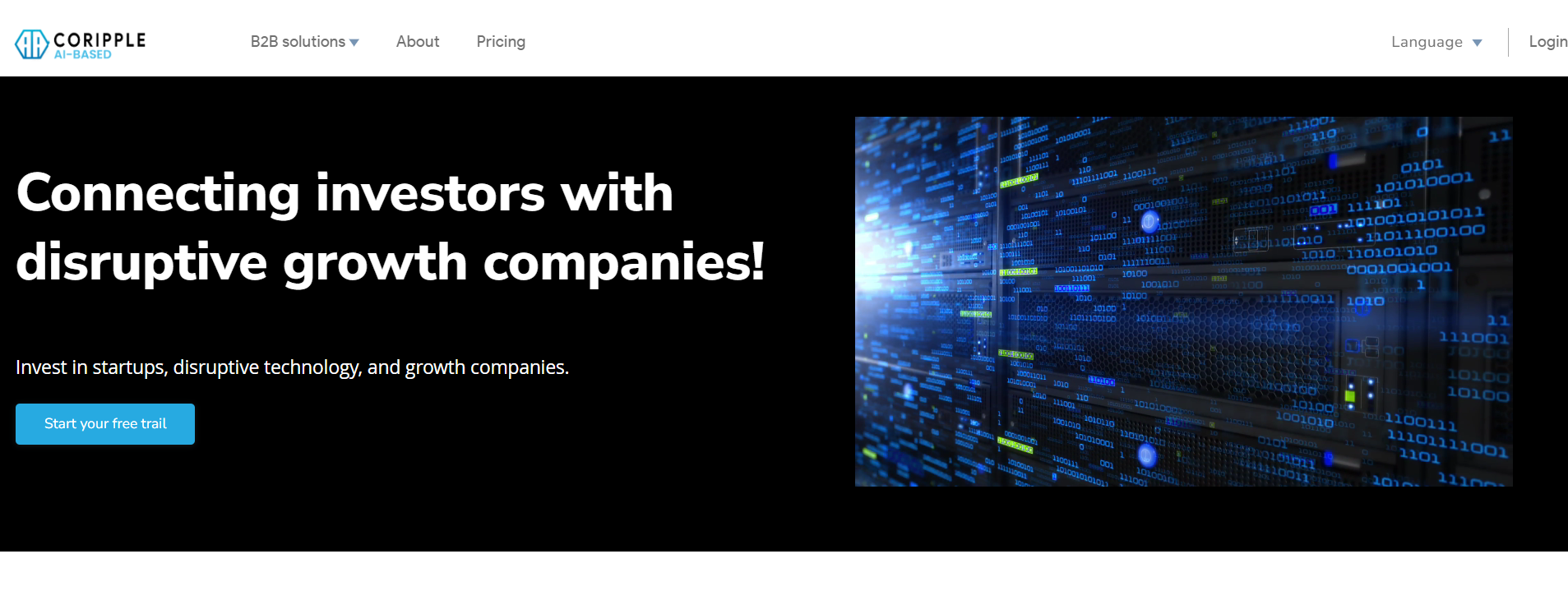
2
- A network for investors!
Invest in startups, disruptive technologies, and growth companies.
3
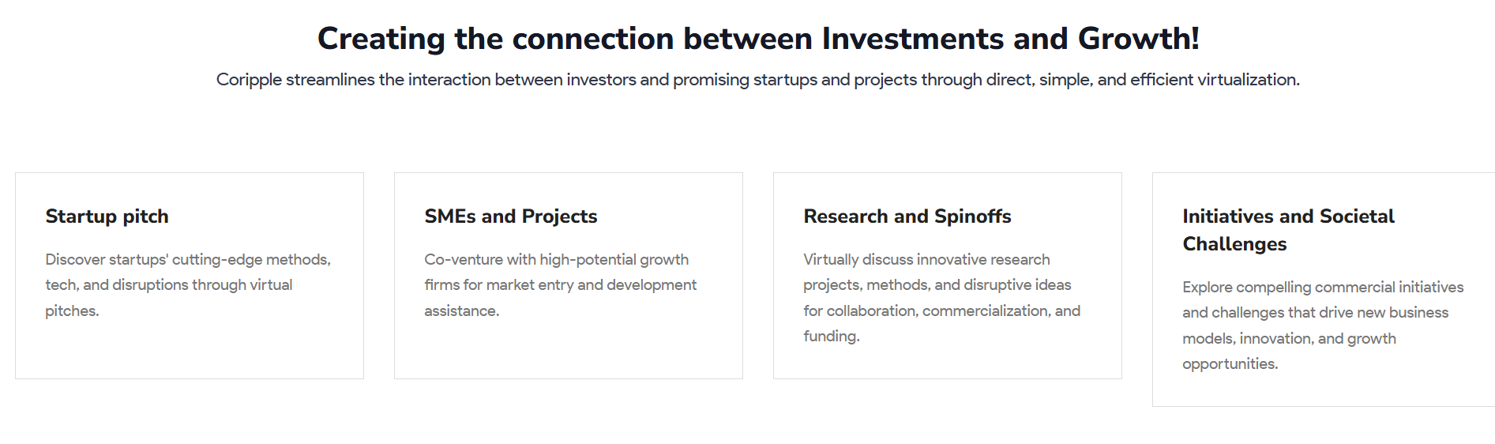
4

- Bridging the gap between investments and growth!
Coripple streamlines interactions between investors and promising startups and projects through direct, simple, and efficient virtualization.

- Startup Pitches
Explore cutting-edge methods, technologies, and innovations from startups through virtual pitches.

SMEs and Projects
Partner with high-potential growth firms for market entry and development support.

Research and Spin-offs
Join virtual discussions on innovative research, methods, and ideas for collaboration and funding.

Initiatives & Societal Challenges
Explore commercial initiatives and challenges driving new business models, innovation, and growth.


5
1
- Investors enter at the right time
By leveraging virtualization, we make interactions between startups and investors more accessible and efficient.
6
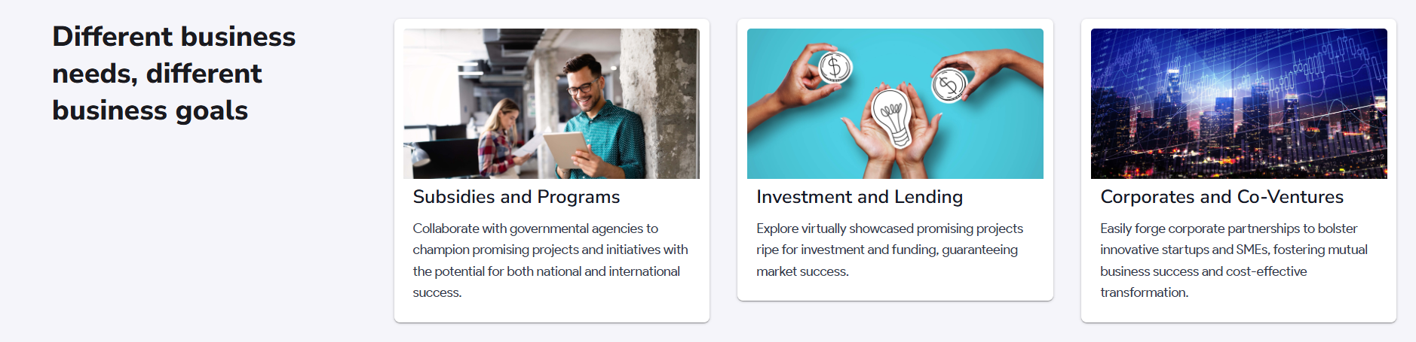
7
- Different needs, different goals
- Subsidies & Programs
Partner with government agencies to support promising projects with national and international potential.

Investment & Lending
Explore promising projects showcased virtually, ready for investment and funding.

Corporates & Co-Ventures
Forge corporate partnerships to support innovative startups and SMEs, driving mutual success and cost-effective transformation.

8
- Enabling direct investor interaction for financial success

https://coripple.com/growth
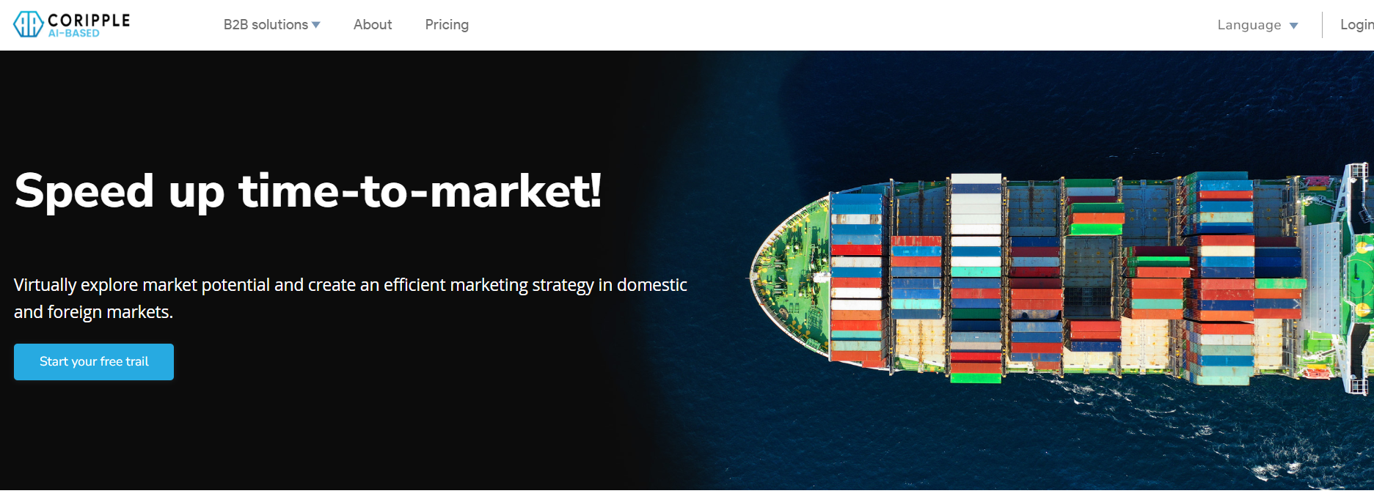
9
- Explore market potential virtually and craft efficient strategies for domestic and international markets.
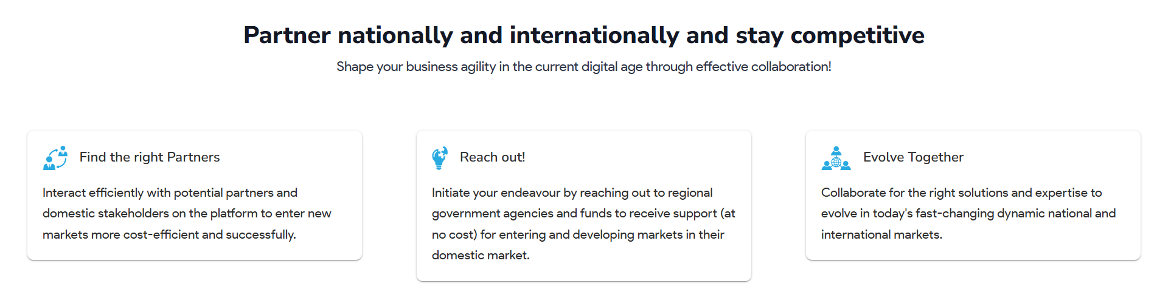
10
11
- Interact efficiently with potential partners and local stakeholders to enter new markets cost-effectively and successfully.
- Start by contacting regional government agencies and funds for free support in exploring and entering domestic markets.


12
- Connect with international organizations and expand across markets by applying to projects and calls. Strengthen your organization’s and partners’ core competencies, agility, and ROI through collaboration and co-venture.
13

- Gain valuable insights through virtual B2B interactions
Interact seamlessly with global business partners, gain insights, and accelerate growth in current and new markets!
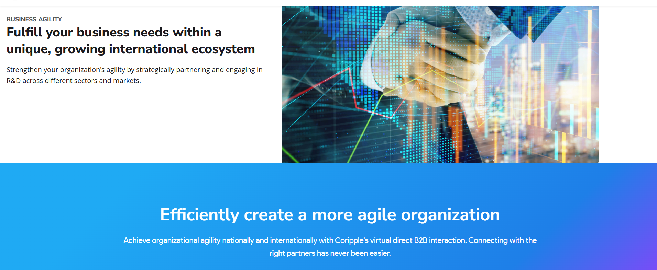
15
14
- Meet your business needs within a unique, expanding international ecosystem
Enhance your organization’s agility by partnering and engaging in R&D across sectors and markets.
- Create a more agile organization
Achieve national and international agility with Coripple’s seamless virtual B2B interactions. Connecting with the right partners is easier than ever.

https://coripple.com/innovation
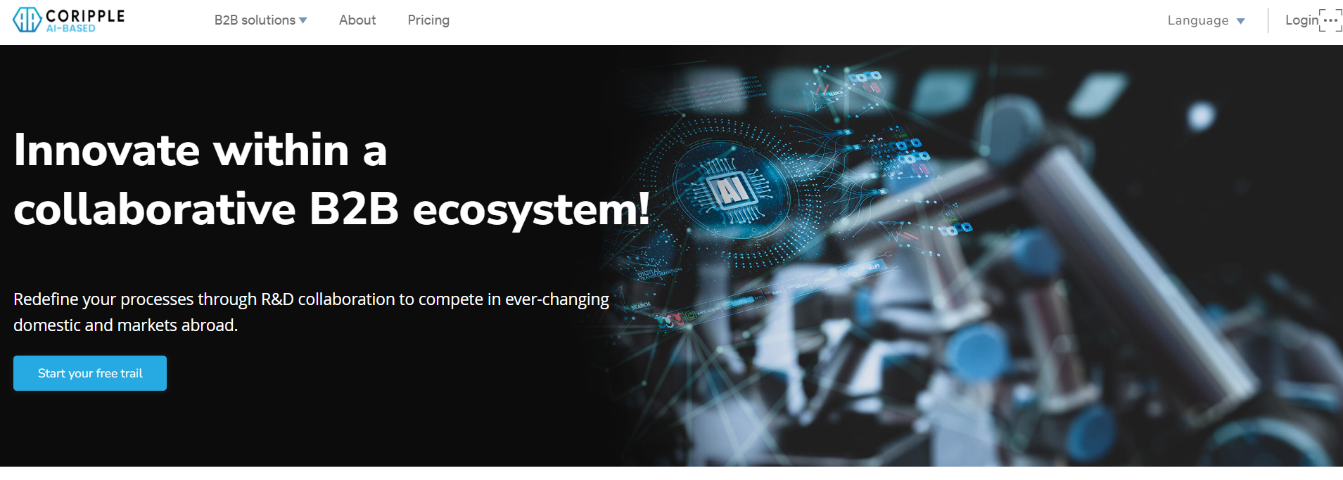
16
- Redefine your processes through R&D collaboration to thrive in dynamic domestic and international markets.
17
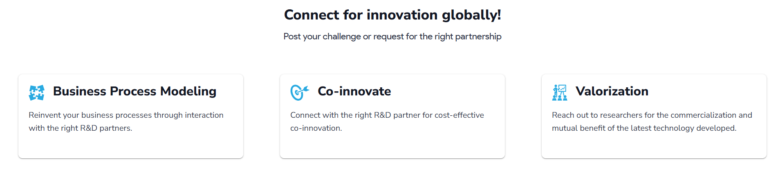
18
- Global connections for innovation!
- Collaborate with researchers to commercialize and mutually benefit from the latest technology.

1
- Find the right R&D partner
Gain insights by interacting with potential R&D partners and align your business with the latest technology and market trends to build a market-centric organization, both nationally and internationally.
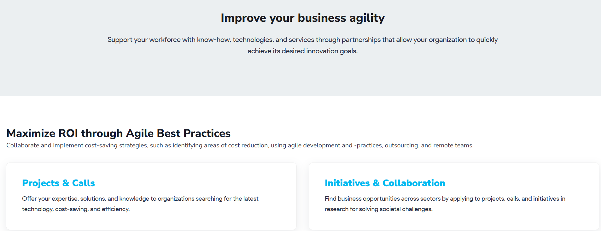
4
3
2
- Enhance your business agility
Empower your workforce with expertise, technologies, and services through partnerships that help achieve innovation goals swiftly.
- Maximize ROI with Agile Best Practices
Collaborate to implement cost-saving strategies, including cost reduction, agile practices, outsourcing, and remote teams.

Projects & Calls
Provide your expertise, solutions, and knowledge to organizations seeking the latest technology, cost savings, and efficiency.

Initiatives & Collaboration
Discover business opportunities across sectors by applying to research projects and initiatives focused on solving societal challenges.
5
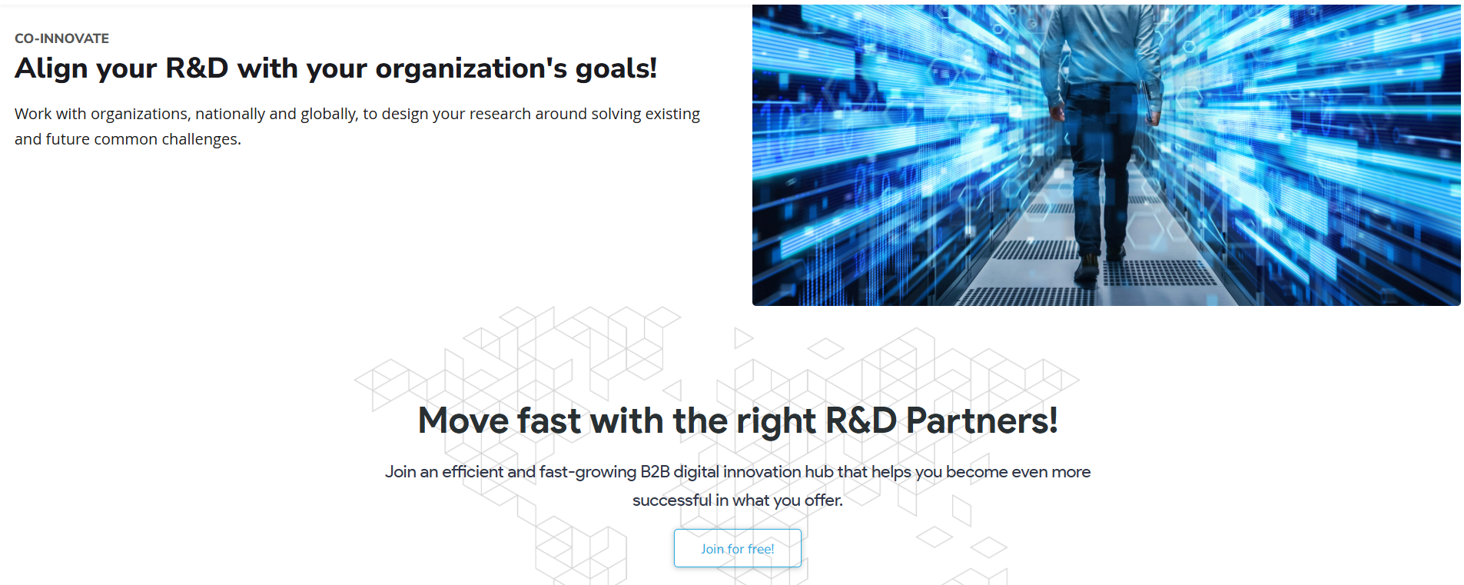
6
- Align your R&D!
- Anticipate and Lead the Way!

