Hi Mridulla,
2
1
4
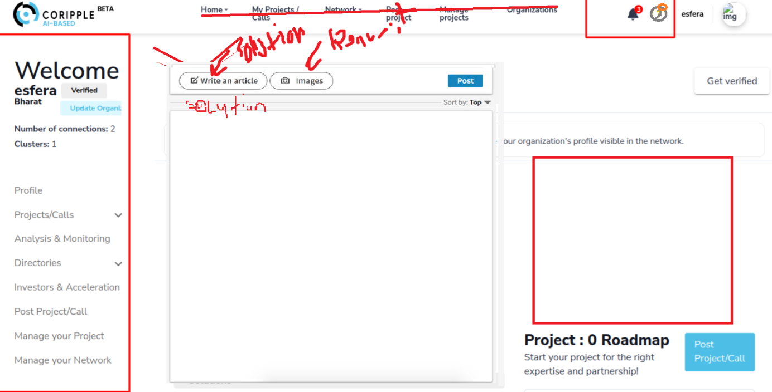
5
6
7
3
- The menu text should be removed.
- For the question mark, use a yellow circle instead of making it fully yellow.
- Place "Verified" and "Update Profile" here.
- Move the feed up, ensuring it scrolls like LinkedIn. Add two buttons: "Solutions" and "Requests."
- When either the "Solutions" or "Requests" button is selected, display the related text for that section in the box below the two buttons.
- Clicking a button should update the section below accordingly. On the right, allow users to sort by sectors. Add a reply section under the feed boxes.
- When either button is selected, users should be able to create a post within the respective section.
- Add the three notifications here. Once all notifications are resolved, the section below should move upward.

