Hi Mridulla,
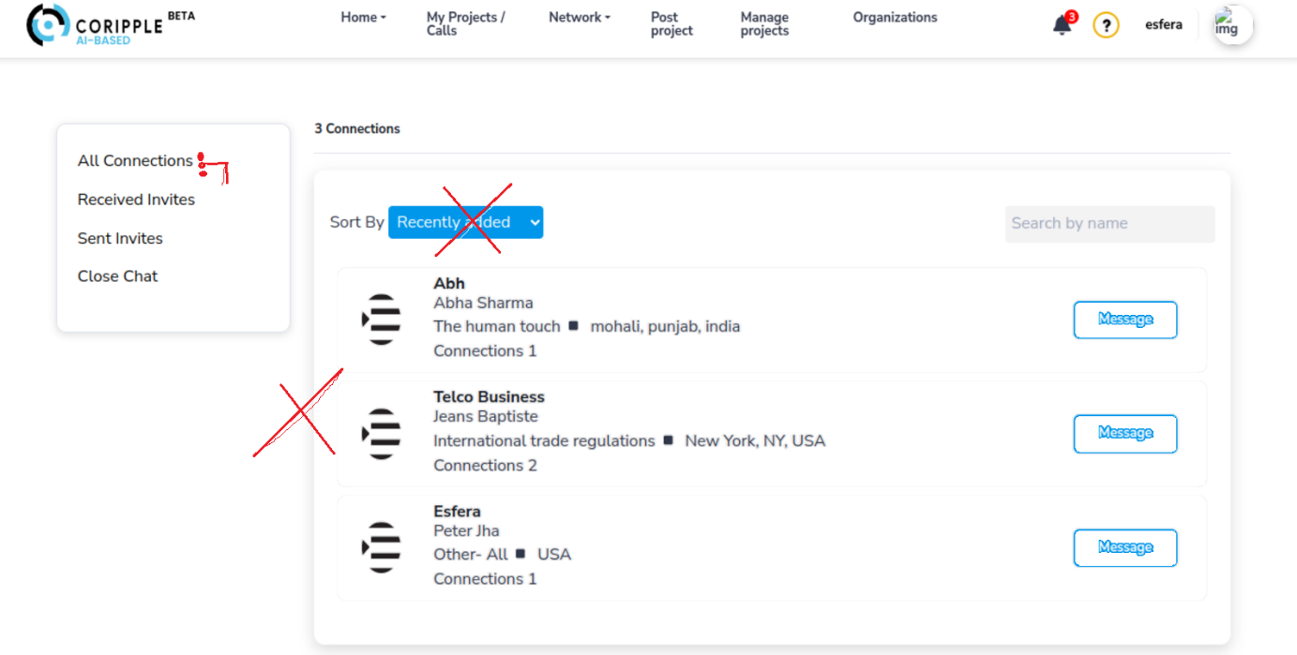
2
4
3
1
- For a clean, simple design, can you create a dropdown with three dots? When clicked, the dropdown should appear with the following options:
- Received invites
- Sent invites
- Close network page
- Remove the blue button; instead, use bold text next to "Sort by."
- Remove the blurred shade and leave only the outline.
- Creat a blue outline design
1

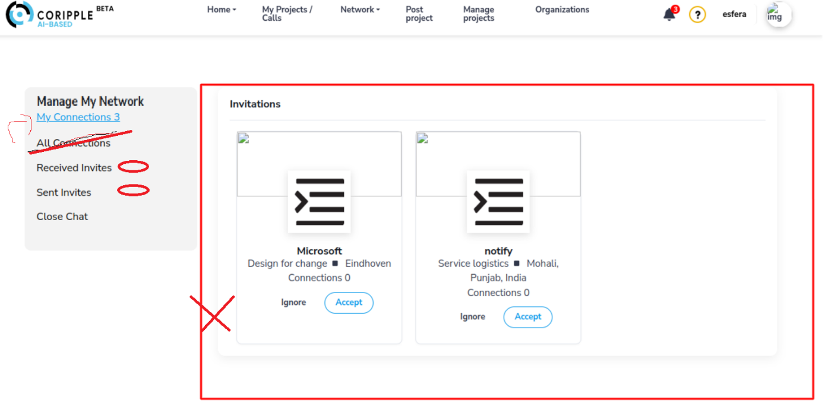
1
- Remove the text "Connections." Can you place numbers next to "Received Invites" and "Sent Invites"?
- Remove the blurred shadow and leave only the outline
2
1
1
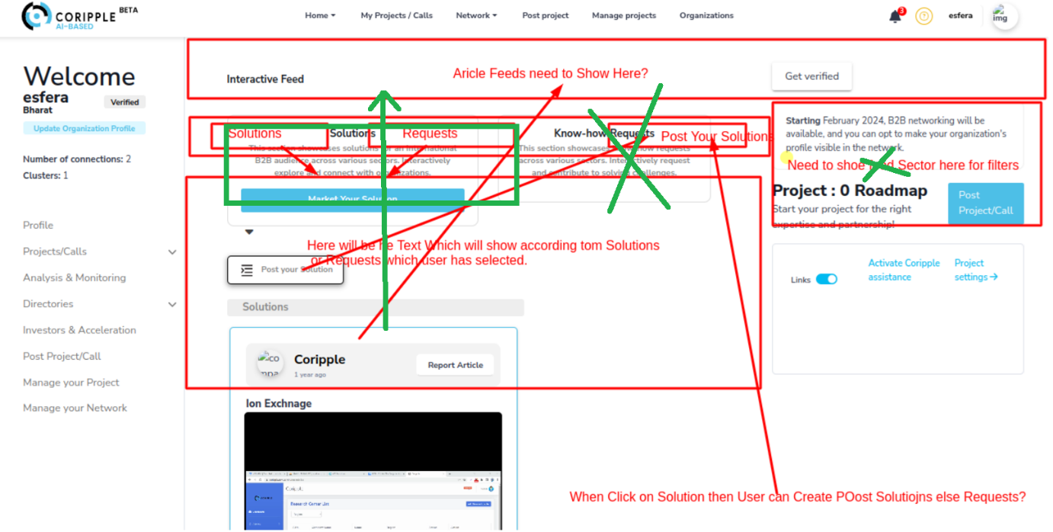
- Our feed should be clean and simple, similar to Facebook or LinkedIn, with no complex setup. It should scroll up, similar to Facebook, Linkedin.
- Here, the three notifications in a box should appear, or we can place them in a box, above the feed.
Please scroll down.
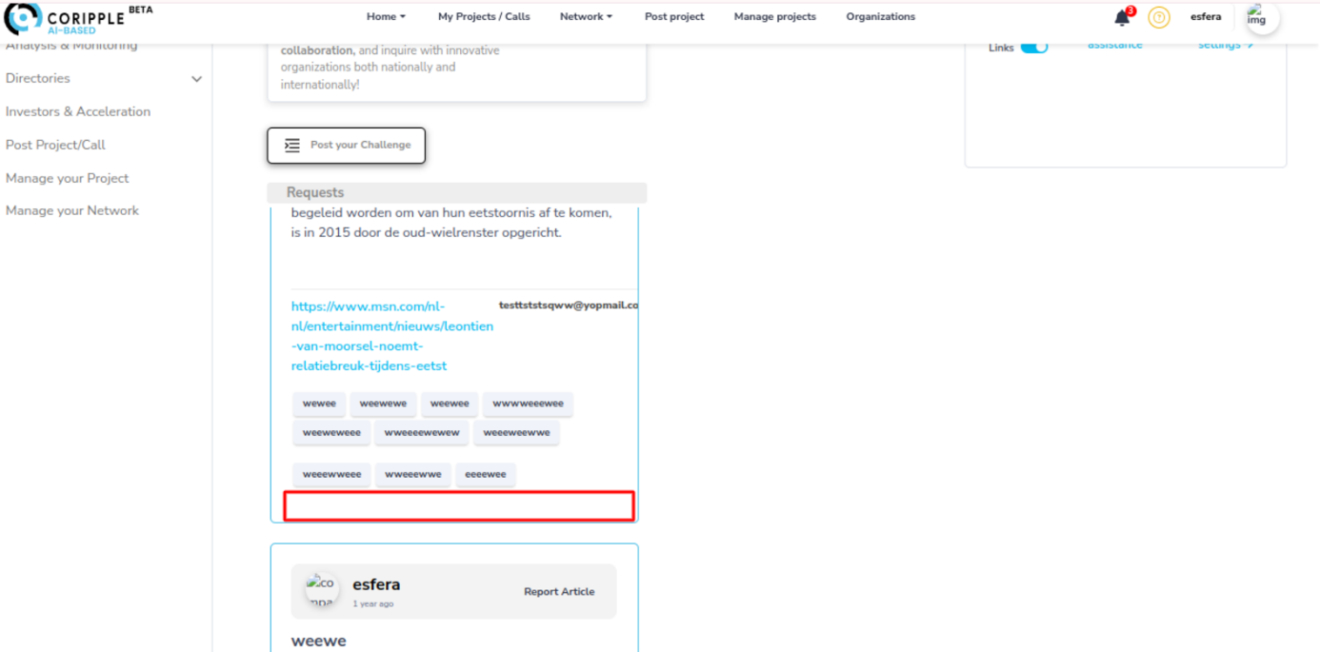
1
- Comments on an article should be similar to those on LinkedIn or Facebook.
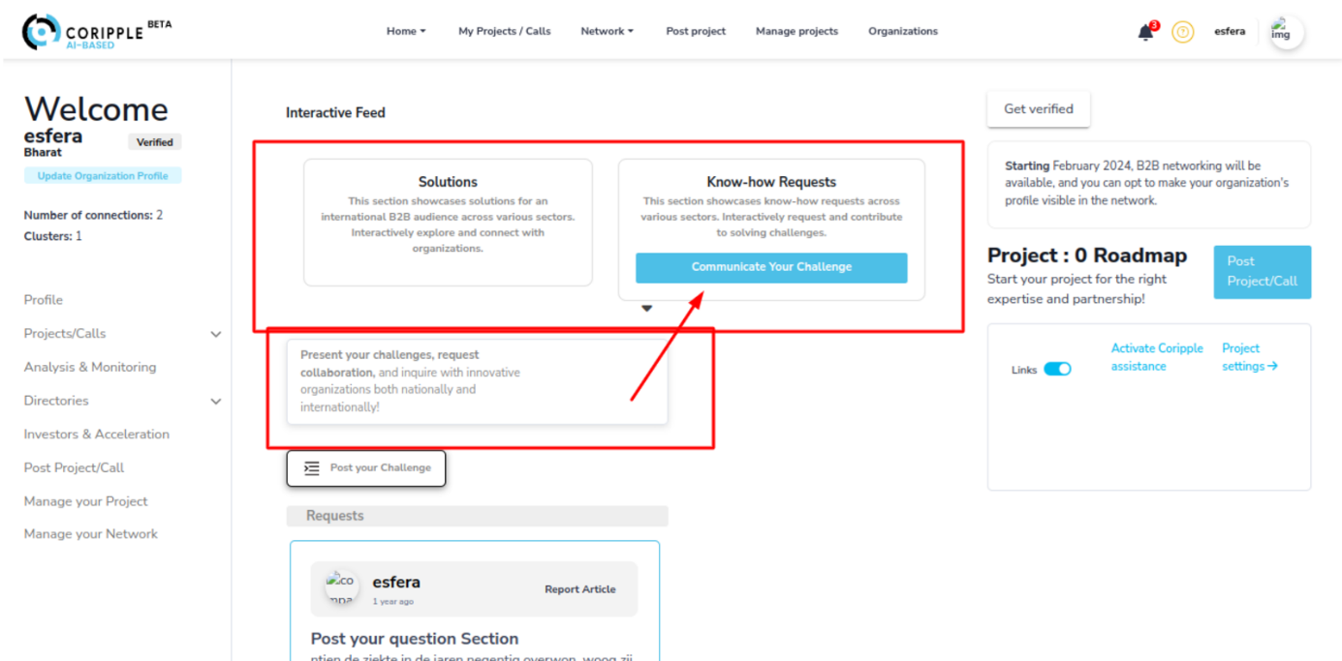
2
- These two boxes should not be like they are now, but rather combined into one box, or maybe stacked above the feed. However, they should not be wider than the feed.
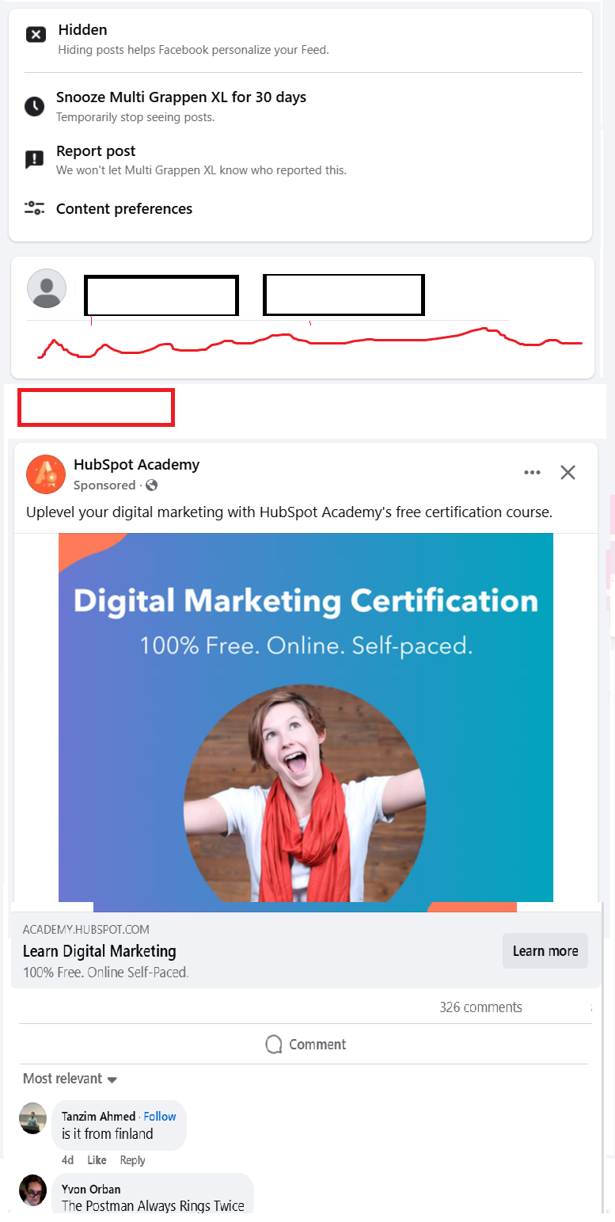
6
4
1
2
3
5
1
The homepage needs to be clean and simple:

- We can place the three notifications above the feed section, either in a box or to the right.
- Replace the two boxes with one box containing two buttons: "Market your solution" and "Post your request." When clicked, a pop-up box should appear, as we have now.
- Below the selected button, we should have a brief description of what it’s about.
- The button for "Post solution" or "Post request" can remain here. But no blurred shadow, just dark black outline.
- The feed remains the same: clean and simple.
- Comments should be similar to Facebook and LinkedIn. Please check both platforms.

Mirdulla, I will have no internet access from December 1st to 5th. I will be back on December 10th. It is not feasible for me to provide feedback as I do now during this time. After December 10th, I will review the website again and provide complete feedback by December 16th. We should be able to wrap up quickly. Let's restart on the 16th.

