Two components:

- Extracted structured data to a postgres db
- Chatbot to ask any questions regarding data contained in these PDFs

Planning Dataset: 163 Gb, 23k PDFs (total dataset 1tb, 200k PDFs) Estimated 85% digital PDFs with vector, 15% scanned images (phase 1: PDF to text and get chatbot to work, then phase 2: OCR scanned and ingest).

Spreadsheet of summary of all developments lodged (address/description/status e.g. Awaiting outcome, Granted, Rejected).
Description: Planning applications
Structure:
1. Application Form very structured (Applicant, Description of Development, Contact Details, Estimated Construction cost
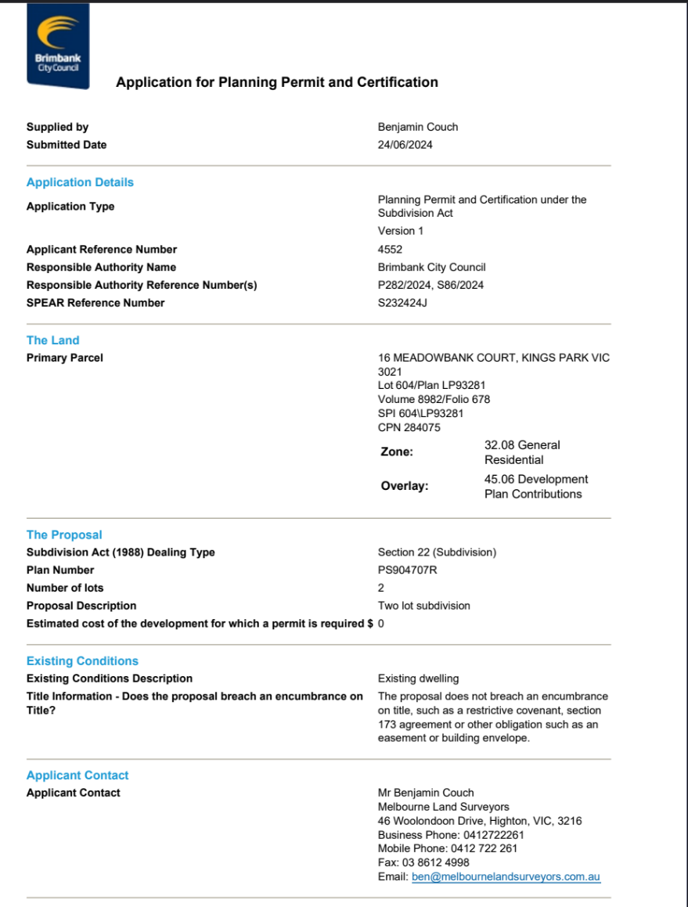
2. Plans: Plan view (bird's eye view), elevation view (side view) - Main section to capture is the development summary (also known as dwelling/site analysis) which is a summary of the land area/building area (number of bedrooms, levels etc).
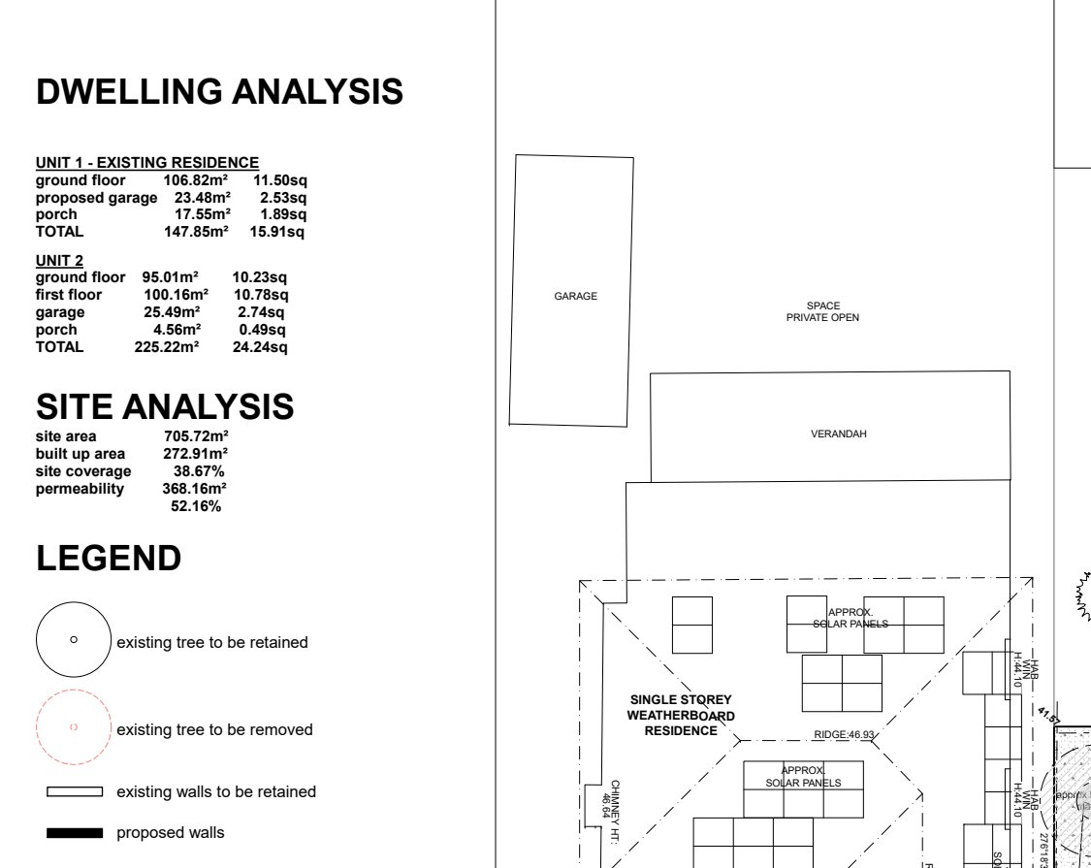

- Supporting Reports: Planning report, Acoustic Report, Urban Design Report etc - Main section to capture is the planning report and the consultant's name/company etc.
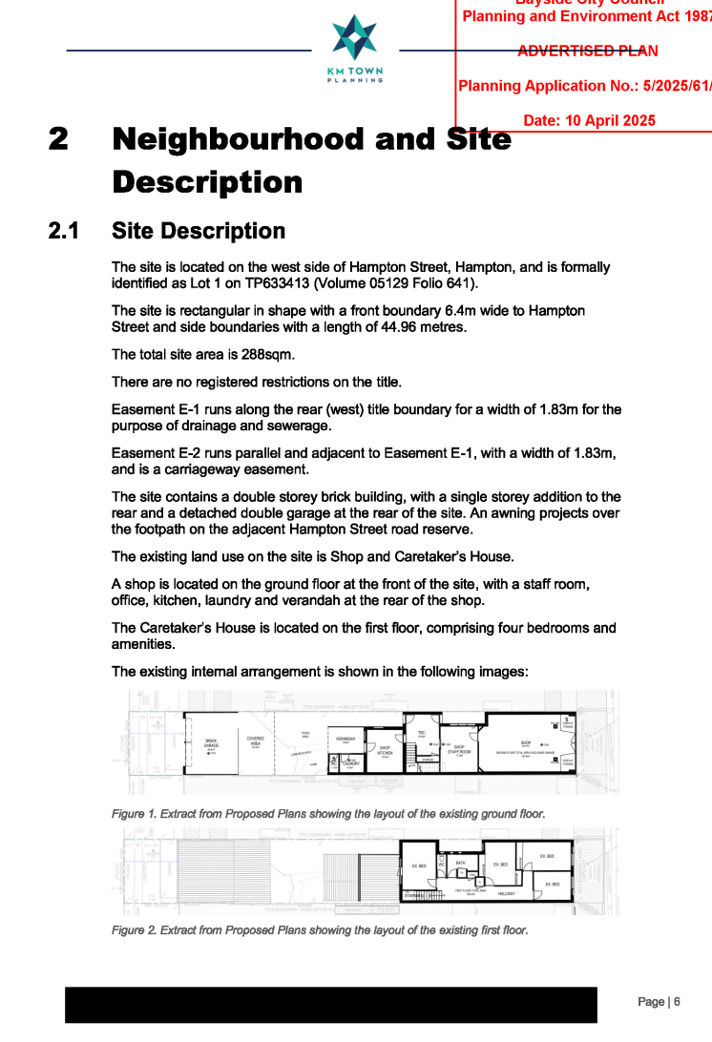

Possible User questions:
- How many childcare applications were lodged between 2023-2025, what was the average number of places per childcare? Can you output a table listing the suburbs and the number of childcares
- What is the average land area for a 4 storey apartment building?
- List all of the fast food restaurant applications made within suburb X
- Give me a list of planning applications, addresses and summary of the development for Bunnings (Hardware store) in the last 2 years in a CSV.
- I'm considering buying a land at location Y, based on the land size and zoning, and based on all the planning applications that successful in the last 5 years, what are the possible types of developments suitable here? Please give me examples of successful applications and show me plans from these.
- Give a list of the top 3 architects for office developments, list their projects in a table
- Is there supporting evidence from any acoustic reports that the volume on road X exceeds 70 dB?

